SPECIAL MEETING AGENDA
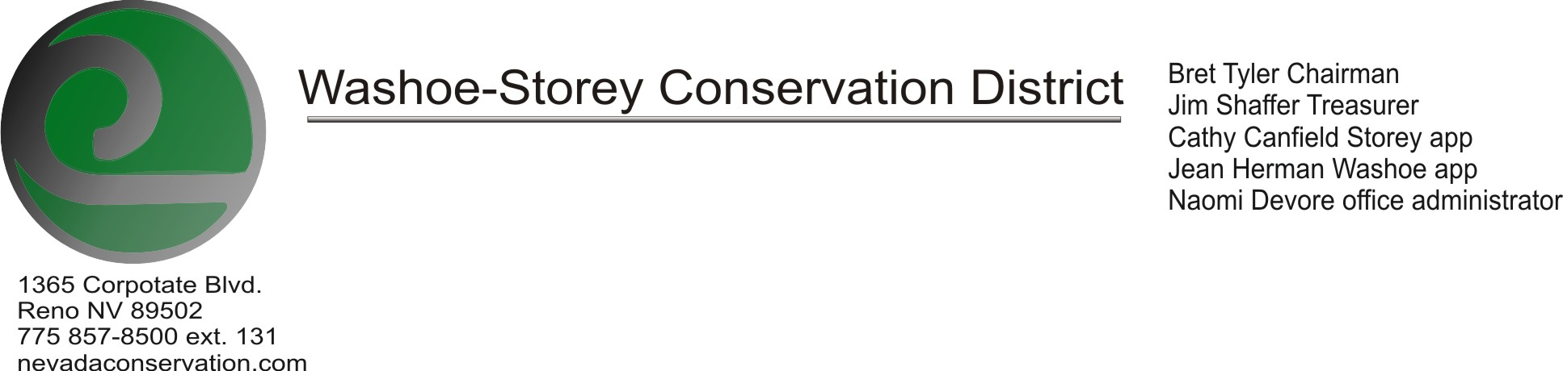

The Washoe-Storey Conservation District has scheduled a public meeting Monday, September 30, 2019 commencing at 10:00 AM. The meeting will be held at NRCS office 1365 Corporate Blvd. Reno, NV 89502.
The Conservation District will consider and will take action on the following items unless otherwise noted:

I. Call to Order
A. Determination of Board Quorum and Introduction of Guests.
B. Determination of agenda order – Agenda items may be taken out of order or deleted for lack of time

II. Public Comments
Public comment will be allowed at the beginning, after each item on the agenda and prior to the adjournment of every meeting. Public comment may be limited to three (3) minutes per comment.

III. Special Meeting Item – For Action
- Review and Approve Annual Plan and Budget

IV. Public Comments
Public comment will be allowed at the beginning, after each item on the agenda and prior to the adjournment of every meeting. Public comment may be limited to three (3) minutes per comment.

V. Next Scheduled WSCD Board Meeting – (1st Monday) October 7, 2019 3:30PM (Tentative)

VI. Adjourn – Action

