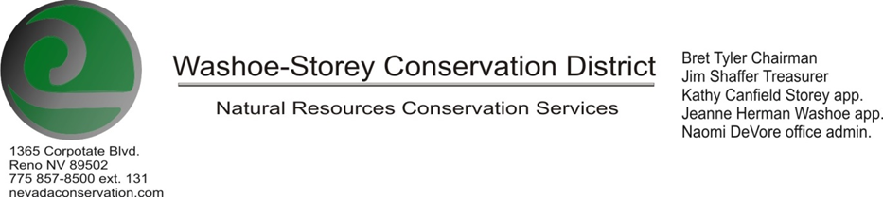
AGENDA 02/10/20
The Washoe-Storey Conservation District has scheduled a public meeting Monday, February 10 commencing at 3:30 p.m. The meeting will be held at NRCS office 1365 Corporate Blvd. Reno, NV 89502.
The Conservation District will consider and will take action on the following items unless otherwise noted:
I. Call to Order
A. Determination of Board Quorum and Introduction of Guests.
B. Determination of agenda order – Agenda items may be taken out of order or deleted for lack of time
II. Public Comments
Public comment will be allowed at the beginning, after each item on the agenda and prior to the adjournment of every meeting. Public comment may be limited to three (3) minutes per comment.

III. External Agency Items and Reports – For Possible Action
A. NRCS – Jim Gifford/ Lakeisha Barber– Updates
B. NDCP – Zachary Ormsby– Updates
C. DCNR – Melany Aten – CD program/Washoe Dam Updates
D. NDOW – Bobby Jones - Partner Biologist –Perry Fire Project Updates
E. NVACD, Adjacent CD- Updates and Grants
F. WSCWMA- Updates
G. Other Partner- Updates

IV. District Projects – For Possible Action
A. Storey County Projects – Kathy Canfield
B. Little Washoe Dam- Review Proposals and Alternatives
C. Sage Grouse Projects- Updates
D. Washoe and Storey County Planning Reviews- Review to approve standardized language
E. New Projects- Potential River Clean-Up, Perry Fire Projects and Partnerships

V. Internal District Issues – For Possible Action
A. Review, Amendment, and Approval of Minutes from previous meetings
B. Financial Reports, -Treasurer Jim Shaffer
• Treasurers Report – Funding Updates, Checks written, Expenditures, Balances
• Mileage Reports – Submit, Review and Approve Allocation of Funds for Mileage
• Employee Salary- Submit, Review and Approve Payment for Employee Hours
C. Discuss, Review and Approve Appointment of Officers
• Fill Vacancies – Oath of Office for Sean Gephart
D. Office Correspondence- Update

VI. Public Comments
Public comment will be allowed at the beginning, after each item on the agenda and prior to the adjournment of every meeting. Public comment may be limited to three (3) minutes per comment.
VII. Next Scheduled WSCD Board Meeting – Tentative March 9 (2nd Monday)
VIII. Adjourn – Action

