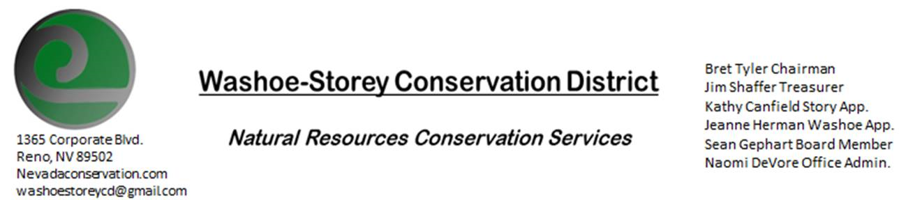

AGENDA 03/09/2020

**The Washoe-Storey Conservation District has scheduled a public meeting Monday, March 9 commencing at 3:30 p.m. The meeting will be held at NRCS office 1365 Corporate Blvd. Reno, NV  89502.**

The Conservation District will consider and will take action on the following items unless otherwise noted:

**I. Call to Order**

   A.  Determination of Board Quorum and Introduction of Guests.

   B.  Determination of agenda order – Agenda items may be taken out of order or deleted for lack of time

**II. Public Comments**

Public comment will be allowed at the beginning, after each item on the agenda and prior to the adjournment of every meeting.  Public comment may be limited to three (3) minutes per comment.

**III. External Agency Items and Reports – For Possible Action**

     A.  NRCS – Jim Gifford/ Lakeisha Barber– Updates

     B.  NDCP – Zachary Ormsby– Updates

     C.  DCNR – Melany Aten – CD program/Washoe Dam Updates

     D.  NDOW – Bobby Jones - Partner Biologist –Perry Fire Project Updates

     E. NVACD, Adjacent CD- Updates and Grants

     F. WSCWMA- Updates

     G. SETT- Sage Grouse Adaptive Management Response Meeting Updates

**IV. District Projects – For Possible Action**

A. Storey County Projects – Kathy Canfield

B. Sage Grouse Projects- Updates

C. Little Washoe Dam- Review Proposals and Alternatives

D. Washoe and Storey County Planning Reviews- Updates

E. Goals and Potential New Projects

**V. Internal District Issues – For Possible Action**

A. Review, Amendment, and Approval of Minutes from previous meetings

B. Financial Reports -Treasurer Jim Shaffer

• Treasurers Report – Balances, Funding Updates, Checks Written, Past and Future Expenditures

• Employee Salary- Submit, Review and Approve Payment for Employee Hours

C. Discuss, Review Appointment of Officers

D. Office Correspondence- Update

**VI. Public Comments**

Public comment will be allowed at the beginning, after each item on the agenda and prior to the adjournment of every meeting.  Public comment may be limited to three (3) minutes per comment.

 V**II. Next Scheduled WSCD Board Meeting** – Tentative April 13 (2nd Monday)

**VIII. Adjourn – Action**