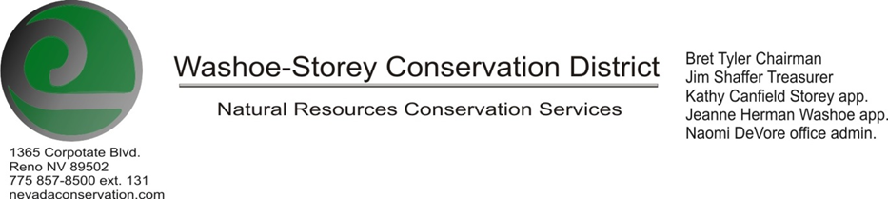
10/28/19 MINUTES

The Washoe-Storey Conservation District held a public meeting Monday, October 28 commencing at 3:30 p.m. The meeting was held at NRCS office 1365 Corporate Blvd. Reno, NV 89502.
I. Call to Order
A. Determination of Board Quorum and Introduction of Guests- Bret Tyler, Kathy Canfield, Jim Shaffer, Naomi DeVore, Bobby Jones, Melany Aten over the phone.
B. Determination of agenda order – Agenda items may be taken out of order or deleted for lack of time
II. Public Comments
Public comment will be allowed at the beginning, after each item on the agenda and prior to the adjournment of every meeting. Public comment may be limited to three (3) minutes per comment.
III. External Agency Items and Reports – For Possible Action
A. NRCS – Jim Gifford – Absent
B. NDCP – Bettina Scherer – Bettina’s replacement, so far unannounced, will be taking over at the end of this year.
C. DCNR – Melany Aten – Commented on Annual Meeting and Washoe Dam Project (detailed below)
C. NDOW – Bobby Jones - Partner Biologist – Presented a plot of land 750-800 acres burnt in the Perry Fire. This land is in Washoe County in the Buffalo Hills and contains creeks and about 1 mile of creek. The landowner and landowner’s daughter (a noxious weed expert) are asking for help to support native regrowth. Suggested projects may include fencing off riparian zones to encourage regrowth, spraying herbicide and reseeding. We will get in contact with landowner’s daughter Andrea to start working on a project here.
D. NVACD, Adjacent CD- Annual Meeting Summary- Bret, Naomi, and Bobby attended the Annual NVACD Meeting in Winnemucca last week. Day 1 of the conference included a Soil Health Demonstration in Orovada, NV with emphasis on minimizing disturbance (no till), maximizing diversity of life, maintaining cover crops and microorganisms, and introducing livestock. We saw improved water infiltration in healthy soil structures. The second day featured many different speakers on the subject of soil health. There was also a presentation from Southern Nevada CD regarding resource conservation practices in large tourist cities like Las Vegas.
E. WSCWMA- The weed group plans to meet on Wednesday, October 30.
F. Other Partner-

IV. District Projects – For Possible Action
A. Storey County Projects – Kathy Canfield- The Mark Twain area is beginning a solar project. The Gold Hill area was approved for a permanent sewer solution, there has been a temporary solution in place to prevent septic leaching.
B. Little Washoe Dam- Melany has been communicating with Megan Kelly, an engineer working with Tahoe CD, to produce a Request for Proposals for the Dam. The RFP will include historical background information for the site and a request for alternative solutions. The RFPs will be sent to washoestoreycd@gmail.com. We’d also like to host regular end-of-the- month check-ins over the phone with Big Ditch Company and stakeholders. Our goals are to develop outreach and host a discussion with stakeholders and potential donors to explore the options. Aim to meet with stakeholders once we get the RFPs back and have NDOT review the plans. We also will need to develop long term maintenance plans and implement an annual monitoring process. WSCD will keep a file specific to this project.
C. Sage Grouse Tags- Nevada Dept. of Forestry has been giving similar tags away for free which were made by prison labor.
D. Washoe and Storey County Planning Reviews-Jim Shaffer and Spencer Scott have been drafting language to streamline consistent responses for multiple planning reviews per week. There were 10 planning reviews sent in during the last 2 weeks including monopoles, accessory buildings, seed mixes and revegetation.
E. Poster Contest- Despite extending the poster contest to over 50 teachers in our area, there were no applicants for the contest. There were few applicants turned in to the state overall. Next year WSCD’s goals for the project will be to contact teachers even earlier to get them to incorporate the contest into their curriculum. Next Year’s Theme focuses on bees and pollinators.
F. New Projects- Potential River Clean-Up Project- We’d like to implement continuous maintenance and more receptacles to keep the river clean in urban areas, as opposed to semi-annual cleanups which remove huge amounts of waste periodically. This could involve partnerships with Waste Management and the Sheriff’s Department Community Service Program. Melany suggests a partnership with Keep Truckee Meadows Beautiful. They would help organize volunteers if we propose a location and sponsor the event by providing lunch and water.
V. Internal District Issues – For Possible Action
A. Review, Amendment, and Approval of Minutes from previous meetings- Naomi had already corrected some of the changes that Jim and Kathy suggested. Kathy makes a motion to approve the minutes with these edits, Jim Shaffer seconds.
B. Financial Reports, -Treasurer Jim Shaffer
• Treasurers Report – Mitigation- $13,044.85--- Checking $874. 48---
Recent expenses included lodging and registration for the NVACD annual meeting.
• Mileage Reports – Mileage forms for annual meeting will be paid off in the New Year once more funding comes in.
• Employee Salary- Naomi is to be paid for 44 hours for September and October, to complete the annual budget and attend the annual meeting.
C. Discuss and Review Appointment of Officers
• Fill Vacancies – Letter of Intent, Oath of Office
D. Office Correspondence- Update

VI. Public Comments
Public comment will be allowed at the beginning, after each item on the agenda and prior to the adjournment of every meeting. Public comment may be limited to three (3) minutes per comment.
VII. Next Scheduled WSCD Board Meeting – We do not plan to host meetings in November and December. Our next meeting will be the 2nd Monday of January 2020, January 13
VIII. Adjourn – Action

