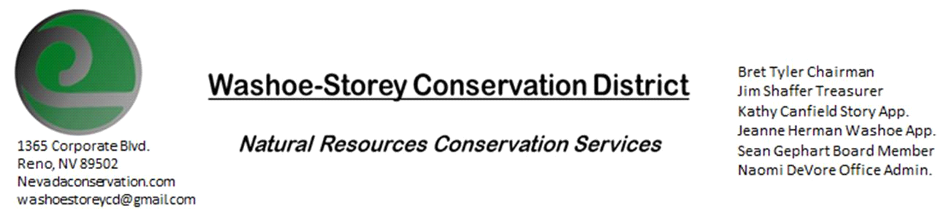
MINUTES 02/10/20
The Washoe-Storey Conservation District held a public meeting Monday, February 10 commencing at 3:30 p.m. The meeting was held at NRCS office 1365 Corporate Blvd. Reno, NV 89502.
The Conservation District considered and took action on the following items:
I. Call to Order
A. Determination of Board Quorum and Introduction of Guests: Bret Tyler, Jim Shaffer, Kathy Canfield, Naomi DeVore, NRCS Conservationist Jim Gifford, Dept. of Ag. Sean Gephart, and NVACD Melany Aten (by phone.)
B. Determination of agenda order – Agenda items may be taken out of order or deleted for lack of time
II. Public Comments
Public comment will be allowed at the beginning, after each item on the agenda and prior to the adjournment of every meeting. Public comment may be limited to three (3) minutes per comment.
III. External Agency Items and Reports – For Possible Action
A. NRCS – Jim Gifford– Snowpack Reports around 70%.
Awaiting program rules for the farm bill- no application deadlines yet for EQIP. Irrigation districts may be eligible- to serve many producers rather than individual farmers. this could be beneficial for Washoe Dam. Gifford to take place as acting State Rangeland Management Specialist. Supplied Minden Field Office Report for 2019 financials-63% to California projects. it's typically split 1/3 between cal, washoe-storey, and Carson
C. DCNR – Melany Aten – CD program/Washoe Dam- Adaptive Management Meeting to be held Feb 20- dept of ag. send letter to Bujana.
D. NDOW – Bobby Jones - Partner Biologist – N/A
E. NVACD, Adjacent CD- we need to approve $600 to pay dues to NVACD. Vya Conservation District- no nevada entities recieved funding for wildfire prevention last year.
F. WSCWMA- Upcoming meeting will take place feb24 1-3pm at Nevada Department of Agriculture.
IV. District Projects – For Possible Action
A. Storey County Projects – Kathy Canfield-N/A
B. Little Washoe Dam- We are prepared to review proposals and alternatives upon their submission. planning future meetings to review
rfps with engineers and stakeholders.
C. Sage Grouse Projects- tags for sale. outreach
D. Washoe and Storey County Planning Reviews- jim shaffer has been working on planning reviews- 7 this month
. creating consistent language
Kathy Canfield makes a motion to implement more standard verbage as basis to work from in response to planning reviews. Bret Tyler seconds and the motion carries unanimously.
E. New Projects- Potential River Clean-Up, Perry Fire Projects and Partnerships
V. Internal District Issues – For Possible Action
A. Review, Amendment, and Approval of Minutes from previous meetings- Jim makes motion to approve minutes with minor edit, Canfield seconds and the motion carries unanimously.
B. Financial Reports, -Treasurer Jim Shaffer
• Treasurers Report – additional Mitigation Account: $12,804.85, Checking Account: $4,0768.
• Mileage Reports – Approved Mileage form from out of town meetings to Carson City and Winnemucca
• Employee Salary- Submit, Review and Approve Payment for Employee Hours
C. Discuss, Review and Approve Appointment of Officers
• Fill Vacancies – Oath of Office for Sean Gephart, Gephart was sworn in as WSCD Board Member.
D. Office Correspondence- The board views and makes comments on recent emails.
VI. Public Comments
Public comment will be allowed at the beginning, after each item on the agenda and prior to the adjournment of every meeting. Public comment may be limited to three (3) minutes per comment.
VII. Next Scheduled WSCD Board Meeting – March 9 (2nd Monday)
VIII. Adjourn – Action

