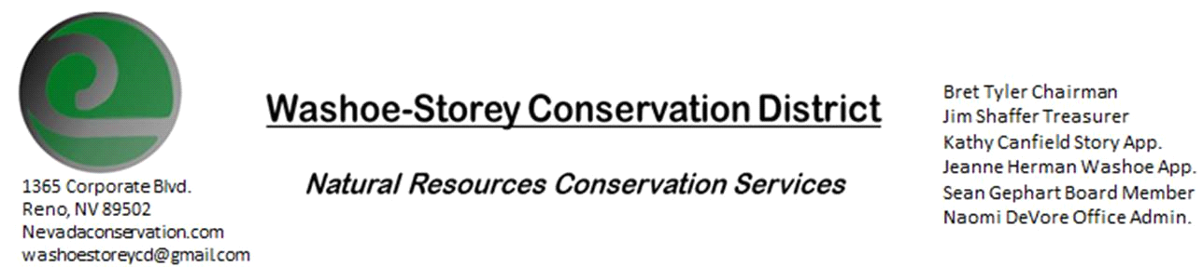

Minutes
The Washoe-Storey Conservation District held a public meeting Monday, March 9 commencing at 3:30 p.m. The meeting will be held at NRCS office 1365 Corporate Blvd. Reno, NV 89502.
The Conservation District will consider and will take action on the following items unless otherwise noted:
I. Call to Order
A. Determination of Board Quorum and Introduction of Guests- Bret Tyler, Kathy Canfield, Jim Shaffer, Jim Gifford, Sean Gephart, Naomi DeVore
B. Determination of agenda order – Agenda items may be taken out of order or deleted for lack of time
II. Public Comments
III. External Agency Items and Reports – For Possible Action
A. NRCS – Jim Gifford– No Updates
B. NDCP – Zachary Ormsby– Updates
C. DCNR – Melany Aten – No Updates
D. NDOW – Bobby Jones - Partner Biologist –No Updates
E. NVACD, Adjacent CD- No Updates
F. Sean Gephart (WSCWMA, NDA)- Announced upcoming meetings WSCD rep. may want to attend meeting held February 24 1-3PM at Dept. of Agriculture, Division of Forestry meeting on March 25 and upcoming Truckee Meadows Water Authority Meeting. Clean-up days are planned to take place on May 2 (KTMB) and June 19 (Rancho San Rafeal Park- Yellow Star Thistle)- WSCD could help by sponsoring lunches and making directional signs for the sites and a statement discouraging target shooting in the area during the clean-up day)
G. SETT- A group gathered to review Sage Grouse Population triggers on Feb. 20. It was discussed that in some of the leks which showed decrease- grouse sometimes travel between multiple nearby leks which could be skewing the data. It was also considered that Virginia Pah Rah range could be split into 2 ranges for data purposes.
IV. District Projects – For Possible Action
A. Storey County Projects – Kathy Canfield- No Updates
B. Sage Grouse Projects- reimbursement for $1500 in tow, see above SETT meeting.
C. Little Washoe Dam- The RFPs were sent out and we are awaiting proposals. We discussed a few more engineering firms and American Society of Civil Engineers to which we'd like to send the RFP.
D. Washoe County Planning Reviews- 14 projects reviewed in March including Golden Valley Subdivision, Boneyard Flats, Pleasant Valley Estates, and a 3- year revegetation plan for a St. Francis of Assisi Catholic Church. The newly approved language was implemented.
E. Goals and Potential New Projects- See above cleanup days and upcoming meetings. As we have additional funding coming in, we can assess how to best utilize this funding towards conservation efforts. Keep website up to date with updated information bios from board.
V. Internal District Issues – For Possible Action
A. Review, Amendment, and Approval of Minutes from previous meetings- Kathy Canfield makes motion to approve the minutes with edits, Gephart seconds, and the motion carries unanimously.
B. Financial Reports -Treasurer Jim Shaffer
- Jim Shaffer makes motion to approve $600 for 2020 NVACD Dues, Canfield seconds, carries unanimously.
• Treasurers Report –Mitigation Account $12,804.85; Checking Account $4,117.14
• Employee Salary- Submit, Review and Approve Payment for Employee Hours
C. Discuss, Review Appointment of Officers- Welcome Sean Gephart. We are not actively looking for new board members at this time.
D. Office Correspondence- Update

VI. Public Comments
VII. Next Scheduled WSCD Board Meeting – April 13 (2nd Monday) [Cancelled]
VIII. Adjourn – Action

