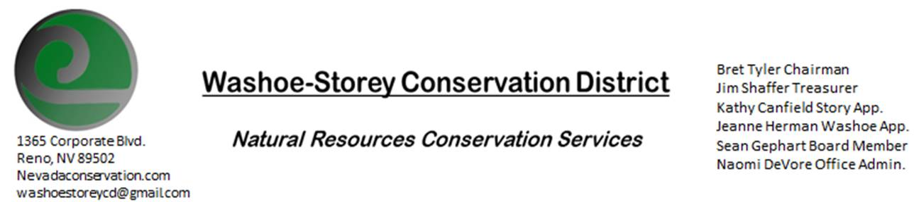
AGENDA 7/13/20
The Washoe-Storey Conservation District will hold a public meeting on Monday, July 13, 2020.
3:30p.m. The meeting will be held digitally via the Zoom app- This is a Public Meeting
to participate please send an email RSVP to washoestoreycd@gmail.com by July 12.

The Conservation District will consider and act on the following items unless otherwise noted:
I. Call to Order
A. Introduction to Zoom, Determination of Board Quorum and Introduction of Guests
B. Determination of agenda order – Agenda items may be taken out of order or deleted for lack of time

II. Public Comments-Public comment will be allowed at the beginning, after each item on the agenda and prior to the adjournment of every meeting. Public comment may be limited to three (3) minutes per comment.
III. District Projects – For Possible Action
A. Little Washoe Dam- Recent Updates from Stakeholder Meeting, Next Steps
B. Washoe County Planning Reviews- Updates
C. Storey County Projects – Kathy Canfield- Updates
D. Sage Grouse Projects- Tags Updates
E. Goals Moving Forward, Potential New Projects- Website Links Updates
IV. External Agency Items and Reports – For Possible Action
A. NRCS – Jessica Gwerder– Updates
B. NDCP – Zachary Ormsby– Updates
C. DCNR – Melany Aten – Updates
D. NDOW – Bobby Jones - Partner Biologist -Updates
E. NDA- Sean Gephart- Updates
F. WSCWMA- Updates
G. NVACD, Adjacent CD- Updates
H. Other Partners- UNR Cooperative Extension Updates
I. Wildfire Updates

V. Internal District Issues – For Possible Action
A. Review, Amendment, and Approval of Minutes from previous meetings-
B. Financial Reports -Treasurer Jim Shaffer
- Treasurer's Report- Balances and Expenditures, Cancelled Expenditures Update
• Employee Salary- Review and Approve Payment for Employee Hours
C. Office Correspondence- CC Email Updates, Covid-19 Updates

VI. Public Comments-Public comment will be allowed at the beginning, after each item on the agenda and prior to the adjournment of every meeting. Public comment may be limited to three (3) minutes per comment.
VII. Next Scheduled WSCD Board Meeting – August 10 (2nd Monday)
VIII. Adjourn – Action

