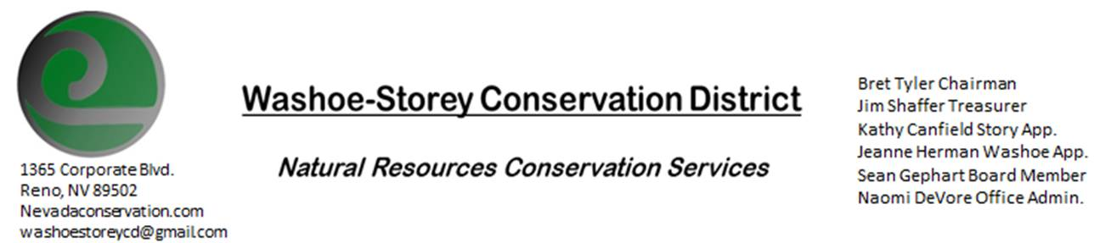
SPECIAL MEETING MINUTES
The Washoe-Storey Conservation District held a public meeting on Friday, May 15, 2020.
10:00a.m. The meeting will be held digitally via the Zoom app-
The Conservation District will consider and act on the following items unless otherwise noted:
I. Call to Order
A. Introduction Determination of Board Quorum and Introduction of Guests:
Bret Tyler, Naomi DeVore, Jim Shaffer, Sean Gephart, Kathy Canfield, Melany Aten
B. Determination of agenda order – Agenda items may be taken out of order or deleted for lack of time

II. Public Comments
III. District Projects – For Action
- Review and Approve Annual Proposed Plan + Budget: The Annual Plan was reviewed and approved as presented. The proposed budget was edited with input from the Board. The final numbers for the proposed budget were approved. A final draft will be prepared by Naomi and sent to Melany by June 1.

IV. External Agency Items and Reports – For Possible Action
- Review and Approve Letter for Washoe County Commissioners detailing how $1500 will be spent: The letter was reviewed and approved as presented and will be sent to Washoe County Commissioners immediately.

V. Internal District Issues – For Possible Action
A. Review and Approve financial report including employee salary from April-May: Jim Shaffer reports on current bank balances. Naomi DeVore’s hours for April-May were reviewed and approved, checks will be mailed.
One other item regarding employee funding was suggested by Kathy Canfield and approved by the board.

VI. Public Comments

VII. Next Scheduled WSCD Board Meeting –
Next Meeting will be planned after an update regarding open meeting law

VIII. Adjourn – Action

