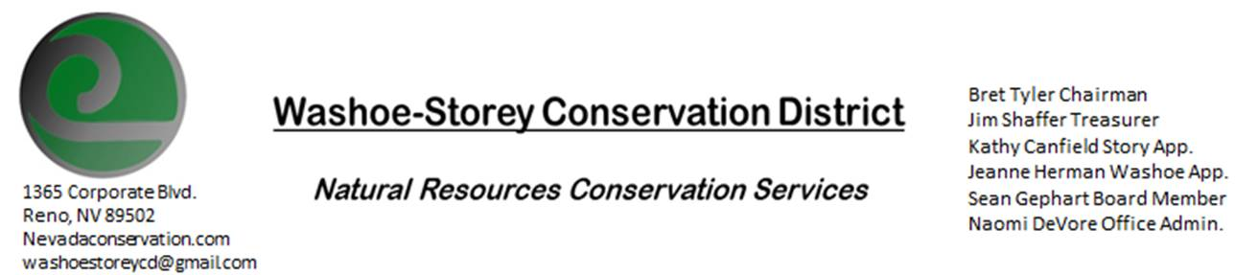
MINUTES
The Washoe-Storey Conservation District held a public meeting on Monday, May 11, 2020
At 3:30. The meeting was held digitally via the Zoom app.
The Conservation District will consider and act on the following items unless otherwise noted:
I. Call to Order
A. Introduction to Zoom, Determination of Board Quorum and Introduction of Guests:
Megan Kelly, Nevada Tahoe Engineer; Bret Tyler; Jim Shaffer, Naomi DeVore; Melany Aten, Sean Gephart, Amanda Brownlee; Jessica Gwerder; Kathy Canfield; Louis Damonte; Chris Thorson; Tim Hunt, NV division of state parks.
B. Determination of agenda order – Agenda items may be taken out of order or deleted for lack of time
a. Approve WSCD Minutes from March- Kathy Canfield makes motion to approve minutes as presented, Jim Shaffer seconds the motion. The motion passes unanimously.

II. Public Comments
III. District Projects – For Possible Action
A. Little Washoe Dam- Jim Shaffer has worked with engineers from both JUB and Cardno and believes them to be about equal. The RFPS are not used to determine which engineers will be selected. Black Eagle, described by Tim Hunt as the premier geotechnical engineers in NV, works in Storey County and sent a proposal in partnership with JUB. JUB and Dyer recently merged. Cardno worked on steamboat creek in years past. We want to choose someone flexible to work with cost planning. NV Tahoe Conservation District Engineers could help with planning. Damonte has worked with both- Dyer and Black Eagle. Jim Shaffer makes motion to select JUB/Dyer/BlackEagle. Bret Tyler seconds and the motion passes unanimously. Tim Hunt approves of this selection. Melany will notify JUB and begin working towards next phase. A meeting will be set up with Big Ditch Company and Stakeholders. Damonte gives an update that a new whirlpool was noticed recently and that hole was plugged. Condition of the dam is currently stable.
B. Washoe County Planning Reviews- Updates. 7 Plans Reviewed this month. 2 were for grading; one for an 18-lot subdivision in Sun Valley, another for an 294-lot subdivision in Golden Valley. Bret likes the suggestions on earth tone colors for new structures.
C. Storey County Projects – Kathy Canfield- No Updates
D. Sage Grouse Projects- Updates- Bret Tyler believes he’ll be selling tags to a fencing company in Northern Nevada.
E. Goals Moving Forward and Potential New Projects- Website Updates, Upcoming Proposed Budget is due June 1. We need to hold special meeting to approve annual plan and proposed budget before the end of the month.

IV. External Agency Items and Reports – For Possible Action
A. NRCS – Jessica Gwerder– New Team Member filling in for Jim Gifford’s old position as State Conservationist in Minden Field Office. EQIP 10 applications- eligibility deadline upcoming Friday. Water supply outlook- 63% of normal as of May 1.
B. NDCP – Zachary Ormsby– Updates. Open meeting law has experienced shifts due to Covid 19 restrictions, an update on open meeting law which may extend current policies will be announced May 16. Due to uncertainties related to this, it is suggested that we hold our budget meeting prior to May 16.
C. DCNR – Melany Aten – Updates. We did not recieve Western Fire Manager’s grant for Washoe and Vya, and are still working with NDOW spring development projects regards to Perry Fire.
D. NDOW – Bobby Jones - Partner Biologist -Absent/No Updates
E. NDA, Noxious Weeds- Sean Gephart- Updates: KTMB Trigger Trash cleanup fell through. Gephart has been transporting trash from top to bottom of Canyon and Bureau of Land Management came to clean up the garbage. The is a lot of Medusahead on BLM land in that area. Washoe County gave Gephart 10 free dump passes. Could do our own cleanup if we have trucks to transport the debris.
F. NVACD, Adjacent CD- Updates: dues have been paid since last meeting

V. Internal District Issues – For Possible Action
A. Review, Amendment, and Approval of Minutes from previous meetings-at beginning of meeting
B. Financial Reports -Treasurer Jim Shaffer
- Treasurer's Report- Balances and Expenditures- technology issues arose with emailing bank statements.
- Ending balance $4,367.99—Quicken books says we have $4767.99. Credit Card purchases from DriAvast software 59.99 from this month and 59.99 last month- should be cancelled. $1500was deposited in our account from Washoe County. 195 written to naomi for office support. Mitigation- 12,784.85 $10 less than last month
- Bret motions to approve treasurers report. Kathy seconds. Unanimously
• Employee Salary- Review and Approve Payment for Employee Hours during next meeting-
C. Discuss, Review Appointment of Officers- Sean Gephart’s oath of office will be sent to Melany Aten immediately
D. Office Correspondence- Update

VI. Public Comments
VII. Next Scheduled WSCD Board Meeting – Special Meeting FRIDAY May 15 10am
VIII. Adjourn – Action

