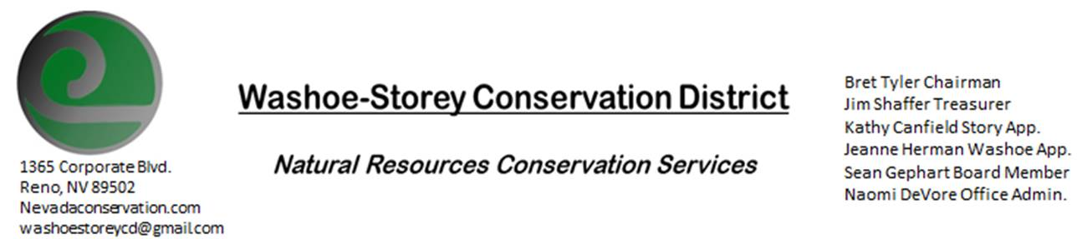
AGENDA 10/12/20
The Washoe-Storey Conservation District will hold a public meeting on Monday, October 12, 2020.
3:30p.m. The meeting will be held digitally on Google Meet- This is a Public Meeting
to participate please send an email RSVP to washoestoreycd@gmail.com by October 11.

The Conservation District will consider and act on the following items unless otherwise noted:
I. Call to Order
A. Introductions, Determination of Board Quorum, and Introduction of Guests
B. Determination of agenda order – Agenda items may be taken out of order or deleted for lack of time

II. Public Comments-Public comment will be allowed at the beginning, after each item on the agenda and prior to the adjournment of every meeting. Public comment may be limited to three (3) minutes per comment.
III. District Projects – For Possible Action
A. Little Washoe Dam- Current Actions and Next Steps
B. Washoe County Planning Reviews- Updates
C. Storey County Projects – Kathy Canfield- Lockwood Weed Removal Updates
D. Sage Grouse Projects- Taxidermy Sage Grouse Follow up, Sage Grouse Tag Sales
E. Goals Moving Forward, Potential New Projects- Web Updates, Invasive Species Book Project
F. Sean Gephart- Noxious Weed Expert, Local Clean-up Events
IV. External Agency Items and Reports – For Possible Action
A. NRCS – Jessica Gwerder– Updates
B. NDCP – Zachary Ormsby– Updates
C. DCNR – Melany Aten – Updates
D. WSCWMA- Updates
E. NVACD, Adjacent CD- Updates
F. Other Partners- Rainbow Bend HOA, UNR Cooperative Extension, Nevada Dept. of Forestry
G. Nevada Wildfire 2020 Updates
V. Internal District Issues – For Possible Action
A. Review, Amendment, and Approval of Minutes from previous meetings-
B. Financial Reports -Treasurer Jim Shaffer
- Treasurer's Report- Balances and Annual Financial Reports Updates, Mitigation Agreement
• Employee Salary- Review and Approve Payment for Employee Hours September
C. Office Correspondence- Email Updates

VI. Public Comments-Public comment will be allowed at the beginning, after each item on the agenda and prior to the adjournment of every meeting. Public comment may be limited to three (3) minutes per comment.
VII. Next Scheduled WSCD Board Meeting – November 9 [2nd Monday]
VIII. Adjourn – Action

