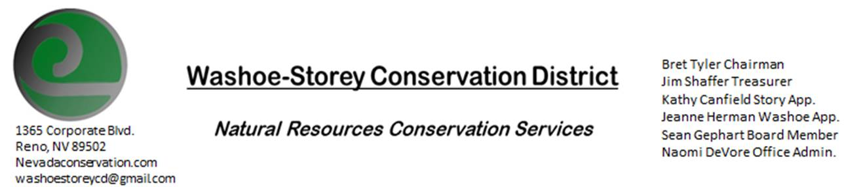

UPCOMING ELECTION
WSCD will hold a public election on Monday, November 9, 2020 11AM.
The meeting will be held in-person at Louise Peri Park [800 Peri Ranch Rd, Lockwood NV 89434]

*Votes cannot be accepted via conference call. Members of the public wishing to vote must attend in person*

The Conservation District will consider and act on the following items unless otherwise noted:
I. Call to Order
A. Roll Call, Determination of Quorum and Others Present
B. Opening Remarks by Members of the Board

II. Public Comments-Public comment will be allowed at the beginning, after each item on the agenda and prior to the adjournment of every meeting. Public comment may be limited to five (5) minutes per comment.
III. ELECTION OF SUPERVISORS
- Eligible Voters sign Poll List
- Supervisor Seats open for Election: Chairperson
  - Term to begin Jan. 4, 2021 and expire December 31, 2024.
- Nominations from the Floor
- Votes taken by secret ballot
- Votes counted
- Election results

VI. Public Comments-Public comment will be allowed at the beginning, after each item on the agenda and prior to the adjournment of every meeting. Public comment may be limited to five (5) minutes per comment.

VII. Next Scheduled WSCD Board Meeting – November 9 (2nd Monday) 3:30pm via Google Meet.
To participate in this meeting, RSVP by email washoestoreycd@gmail.com

VIII. Adjourn – Action

