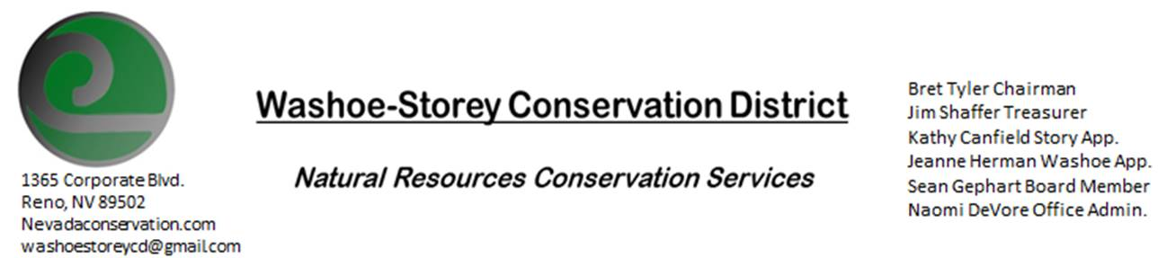
LOCAL WORK GROUP MEETING November 18, 2020 2:30pm
The Washoe-Storey Conservation District will host the Local Area Work Group Meeting on
WEDNESDAY, NOVEMBER 18, 2020. 3:30P.M.
The meeting will be held digitally on Google Meet- This is a Public Meeting
to participate please send an email RSVP to washoestoreycd@gmail.com by November 17.

Nevada State Technical Meeting (STAC) meeting will be held December 9, 2020 and another will be held in the spring of 2021. The meeting is being held to discuss conservation programs, easements and technical assistance administered by the USDA NRCS. The goal of the meeting is to provide information, analysis and recommendations to NRCS and other USDA agencies responsible for natural resources conservation activities and programs. In order to give input to the STAC meeting and determine priorities for the Minden Field Office fund pool there will be a Local Work Group meeting scheduled in November. The Minden Local Work Group Area now includes all of Washoe, Storey, Carson City, and Douglas Counties.

I. Call to Order
A. Introduction of Guests

II. Agenda Items
- Purpose/Organization of the Local Work Group
- NRCS Financial Assistance Programs
- Review Priority Natural Resource Concerns
- Need for New Practices or Cost Adjustments
- High Priority Practices
- State Technical Advisory Committee Meeting December 9th

II. Public Comments-Public comment will be allowed at the beginning, after each item on the agenda and prior to the adjournment of every meeting. Public comment may be limited to three (3) minutes per comment.

