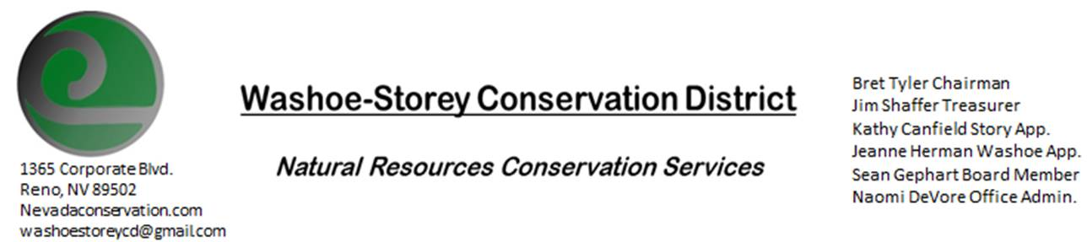
MINUTES 7/13/20
The Washoe-Storey Conservation District held a public meeting on Monday, July 13, 2020.
3:30p.m. The meeting was held digitally via the Zoom app- This is a Public Meeting
to participate please send an email RSVP to washoestoreycd@gmail.com by July 12.

The Conservation District will consider and act on the following items unless otherwise noted:
I. Call to Order
A. Introduction to Zoom, Determination of Board Quorum and Introduction of Guests
Bret Tyler, Naomi DeVore, Kathy Canfield, Jim Shaffer, Sean Gephart, Denise Hilton (Rainbow Bend HOA), Davie Phillips (Rainbow Bend), Melany Aten
B. Determination of agenda order – Agenda items may be taken out of order or deleted for lack of time

II. Public Comments-Public comment will be allowed at the beginning, after each item on the agenda and prior to the adjournment of every meeting. Public comment may be limited to three (3) minutes per comment.
- Rainbow Bend Homeowners Association- Lockwood, NV (Storey County) Denise Hilton and Davey Phillips bring a hemlock problem in their area. What needs to be done and how can we get started. Anna Higgins from NDF can help coordinate a grant- 10am next Tuesday 7/21 to meet at Lockwood Market and look at Invasive species along
Sean Gephart- Hemlock is a biannual weed. You could mow it repeatedly over the course of 3-4 years to prevent it from forming rosettes and going to seed. 24D and Roundup could kill it, but you have to consider site restrictions in riparian areas. Access sometimes require overhead treatment or bringing equipment in by boat. If hemlock is appearing in yards, all neighbors would have to treat it in order to get it completely under control.

*The following Tuesday a group of residents from Rainbow Bend HOA, as well as Anna Higgins from NDF, The Fire Department, Lockwood GID, Bret Tyler, Naomi DeVore, and Kathy Canfield attended a meeting led by Davey Phillips who mapped the weeds along the Truckee River and Long Valley Creek.

- III. District Projects – For Possible Action
A. Little Washoe Dam- A recent field meeting was held at the Dam. They discussed multiple construction options and sent a proposal. Part of their bid includes cost of scoping out the project to make a plan and $7500 to develop a feasibility memo. The original stakeholders agree to pay for this. Once a full cost of the project has been determined, we can look for grants. Jim comments that the contract does not include a plan to develop a longterm maintenance plan to identify all stakeholders and water users.
B. Washoe County Planning Reviews- Updates from Jim Shaffer.
C. Storey County Projects – Kathy Canfield- Updates on Lockwood Poison Hemlock infestations discussed above.
D. Sage Grouse Projects- A large sale of Sage Grouse tags is underway. We have almost no tags left after the sale
E. Goals Moving Forward, Potential New Projects- We agree to upgrade zoom to continue hour-long digital meetings. Up to 4 months of meetings have been approved as part of our operating budget.
IV. External Agency Items and Reports – For Possible Action
A. NRCS – Jessica Gwerder– Updates
B. NDCP – Zachary Ormsby– Updates
C. DCNR – Melany Aten – Washoe Dam Updates
D. NDOW – Bobby Jones - Biologist – No Updates
E. Sean Gephart- Noxious Weed Expert- No longer working with the Department of Agriculture. Working with a company which specializes in custom herbicide mixtures.
F. WSCWMA- Updates- CWMA has not been meeting regularly since March, there is a conference planned.
G. NVACD, Adjacent CD- Updates
H. Other Partners- UNR Cooperative Extension Updates
I. Wildfire Updates

V. Internal District Issues – For Possible Action
A. Review, Amendment, and Approval of Minutes from previous meetings-
B. Financial Reports -Treasurer Jim Shaffer
- Treasurer's Report- Balances and Expenditures, unfamiliar automatic fees from the credit card have been cancelled permanently. Initial conversation regarding a formal mitigation agreement among this board.
• Employee Salary- Review and Approve Payment for Employee Hours
C. Office Correspondence- CC Email Updates, Covid-19 Updates. There were some issues with emails not being sent successfully. Office administrators are working to keep board and community members informed and up to date with forwarded emails.
_
VI. Public Comments-Public comment will be allowed at the beginning, after each item on the agenda and prior to the adjournment of every meeting. Public comment may be limited to three (3) minutes per comment.
VII. Next Scheduled WSCD Board Meeting – August 10 (2nd Monday)
VIII. Adjourn – Action

