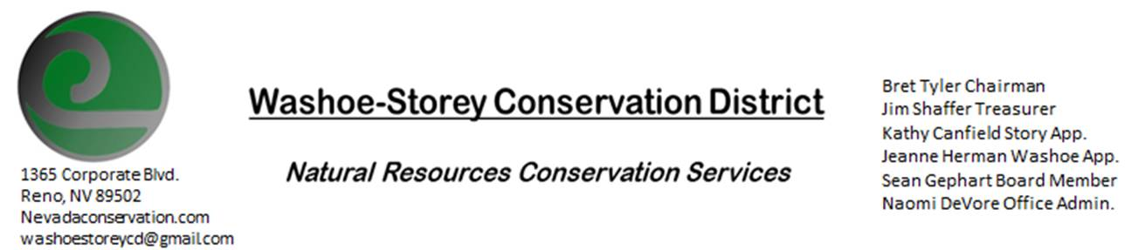
MINUTES 8/10/20
The Washoe-Storey Conservation District held a public meeting on Monday, August 10, 2020.
3:30p.m. The meeting was held digitally via the Zoom app- This is a Public Meeting
to participate please send an email RSVP to washoestoreycd@gmail.com by August 9.

The Conservation District will consider and act on the following items unless otherwise noted:
I. Call to Order
A. Introductions, Determination of Board Quorum and Introduction of Guests:
Bret Tyler, Kathy Canfield, Jim Shaffer, Sean Gephart, Naomi DeVore, DCNR Melany Aten,
Denise Hilton, Davie Phillips, and Larry Huddleson from Lockwood Rainbow Bend HOA
B. Determination of agenda order – Agenda items may be taken out of order or deleted for lack of time

II. Public Comments-Public comment will be allowed at the beginning, after each item on the agenda and prior to the adjournment of every meeting. Public comment may be limited to three (3) minutes per comment.
Larry Huddleson- One of 3 Lockwood residents from Rainbow Bend to discuss weed removal projects along Truckee River and Long Valley Creek in Storey County. Principally concerned with removal of poison hemlock, there are also infestations of purple loosestrife, white top, and multiple species of thistles. These sites can be treated- Controlled burn is an unlikely solution for these areas. WSCD will work with Anna Higgins from NDF to get a grant for removal projects. Biannual Focus on Poison Hemlock over two years to prevent the plants from forming rosettes. Noxious Weed Expert Sean Gephart suggests WeedR64/ 24D for aquatic applications and Rodeo Mix. Cover skin and eyes during removal to reduce exposure.
III. District Projects – For Possible Action
A. Little Washoe Dam- Current Actions and Next Steps: $38,000 toward Washoe Dam- WSCD agreed to contribute $500 towards this. We haven’t gotten more recent updates from the families involved. Notice of Intent- We will make a future agenda item for matching.
B. Washoe County Planning Reviews- None so far for August
C. Storey County Projects – Kathy Canfield- Lockwood Weed Removal Updates discussed during Public Comments
D. Sage Grouse Projects- 17,200 Tags Sold to Emmett Enterprises Fencing company $5000+ for WSCD
E. Goals Moving Forward, Potential New Projects- Challenges encountered in attempts to upgrade our zoom membership to allow for longer meetings may mean that we opt for another video conferencing service.
F. Sean Gephart- Noxious Weed Expert- New Position with EcoPac which services Nevada to remove noxious weeds by providing custom mix of herbicides made specifically to meet environmental needs. He shows us returnable and reuseable containers for ease of use and decrease in human exposure and waste.
IV. External Agency Items and Reports – For Possible Action
A. NRCS – Jessica Gwerder– Updates
B. NDCP – Zachary Ormsby– Updates
C. DCNR – Melany Aten – Updates
D. NDOW – Bobby Jones - Partner Biologist -Updates
E. WSCWMA- Updates
F. NVACD, Adjacent CD- Updates
G. Other Partners- UNR Cooperative Extension Updates
H. Nevada Wildfire 2020- no Updates
V. Internal District Issues – For Possible Action
A. Review, Amendment, and Approval of Minutes from previous meetings- Roll over to next meeting
B. Financial Reports -Treasurer Jim Shaffer
- Treasurer's Report- Balances/Sage Grouse Tag Income,
- September Budget Item- Annual Financial Plans due end of Sept.
- Mitigation Agreement discussion: 2500 was added to the mitigation fund as part of our contingency plan for this fund. Agree to say we can remove up to 10% if needed each year. A final draft will be written to approve during next meeting.
- Motion to approve payment for 4 months of virtual meetings- Jim makes a motion, Kathy seconds. Sean comments that he would like to return to in person meetings.
• Employee Salary- Review and Approve Payment for Employee Hours July
C. Office Correspondence- Email Updates

VI. Public Comments-Public comment will be allowed at the beginning, after each item on the agenda and prior to the adjournment of every meeting. Public comment may be limited to three (3) minutes per comment.
VII. Next Scheduled WSCD Board Meeting – September 14 [2nd Monday]
VIII. Adjourn – Action

