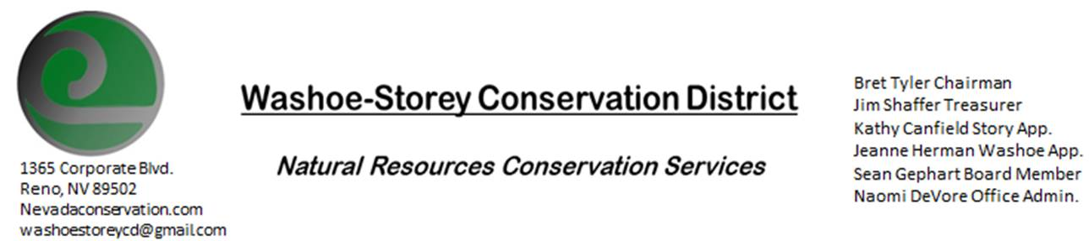
MINUTES 9/13/20
The Washoe-Storey Conservation District held a public meeting on Monday, September 14, 2020.
3:30p.m. The meeting was held digitally on Google Meet- This is a Public Meeting
to participate please send an email RSVP to washoestoreycd@gmail.com by September 13.

The Conservation District considered and acted on the following items :
I. Call to Order
A. Introductions, Determination of Board Quorum, and Introduction of Guests
Kathy Canfield, Jim Shaffer, Denise Hilton (Rainbow Bend HOA), Melany Aten (NRCS), Bret Tyler, Naomi DeVore

II. Public Comments-
III. District Projects – For Possible Action
A. Little Washoe Dam- Current Actions and Next Steps-Melany sent a notice of intent for the High Hazard Program. When funds become available we will begin. Grants will determine funding which causes our timeline to be about 1 year out. The state has filed for FEMA funding for the dam.
B. Washoe County Planning Reviews- Updates- 6 projects this month including an 18-lot subdivision off of Old North Virginia and another subdivision in Golden Valley. Single family residences may require slope stabilization.
C. Storey County Projects – Kathy Canfield- No current updates on Lockwood Weed Removal due to NDF’s focus on recent active wildfires. Weed Management Program on Geiger Grade is being put into place.
D. Sage Grouse Projects- Taxidermy is complete- Melany will arrange for pick up. Another sale is pending for 3,000 sage grouse tags to Ducks Unlimited. We do not have enough tags left, we will have to acquire more tags and make more for the future.
E. Goals Moving Forward, Potential New Projects-Invasive Species Book Project can feature images created by 3 local artists who have agreed to contribute. Bret has looked into where to get these printed.
F. Sean Gephart- Noxious Weed Expert-Will be supervising cleanup crew with Keep Truckee Meadows Beautiful and the Bureau of Land Management at Golden Eagle Regional Park on September 26. WSCD votes to approve up to $50 to sponsor morning donuts for volunteers. This event is mainly aimed at cleaning up trigger trash.
Sean also met with NDF and NV Energy to work on a significant weed management plan around electrical poles and power plants, aim to clear under power lines (reduce fire hazard). Bret reports terrible weed problems under solar farms in Washoe County
IV. External Agency Items and Reports – For Possible Action
A. NRCS – Jessica Gwerder–No Updates
B. NDCP – Zachary Ormsby– No Updates
C. DCNR – Melany Aten – Save the Date for Annual Virtual Meeting. NACD make formatting updates and strategic plans. This is an election year for some WSCD board members.
D. WSCWMA- Updates
E. NVACD, Adjacent CD- Updates
F. Other Partners- Rainbow Bend HOA, Partner Biologist, UNR Cooperative Extension Updates
G. Nevada Wildfire 2020 Updates-Anna Higgins from NDF has been working on active wildfires, leaving our Lockwood Weed Removal Grants on hold for the time being.
V. Internal District Issues – For Possible Action
A. Review, Amendment, and Approval of Minutes from previous meetings- Approved with small edits for July minutes. Approved August Minutes.
B. Financial Reports -Treasurer Jim Shaffer
- Treasurer's Report- Balances and Annual Financial Reports, Mitigation Agreement Mitigation Account: $15, 234.85/ Checking: $6, 789.96. Mel suggests less detail in the document regarding the $1500 from Washoe County. For the Annual Plan- Adjust Supervisor Description for Board Member. Jim makes a motion to approve the Annual Financial Documents with these minor adjustments. Kathy seconds.
• Employee Salary- Review and Approve Payment for Employee Hours August-Staff hours approved.
C. Office Correspondence- Email Updates

VI. Public Comments-
Denise Hilton reports that Rainbow Bend in Lockwood, NV is very dry and concerned about fire. [Denise, Bret, and Naomi met with a member of that community who had a bad infestion of whitetop which had completely taken over his backyard. They gave advice of how to remove the whitetop, giving the resident back use of his yard. The resident was excited to get started and be rid of the infestation.]
VII. Next Scheduled WSCD Board Meeting – October 12 [2nd Monday]
VIII. Adjourn – Action

