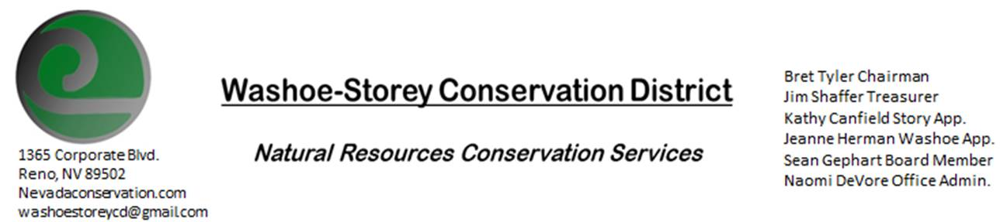
MINUTES 10/12/20
The Washoe-Storey Conservation District held a public meeting on Monday, October 12, 2020.
3:30p.m. The meeting will be held digitally on Google Meet- This is a Public Meeting.

The Conservation District will consider and act on the following items unless otherwise noted:
I. Call to Order
A. Introductions, Determination of Board Quorum, and Introduction of Guests: Naomi DeVore, Bret Tyler, Jim Shaffer, Kathy Canfield, Sean Gephart, Denise Hilton, Paul Scott
B. Determination of agenda order – Agenda items may be taken out of order or deleted for lack of time

II. Public Comments-Public comment will be allowed at the beginning, after each item on the agenda and prior to the adjournment of every meeting. Public comment may be limited to three (3) minutes per comment.
III. District Projects – For Possible Action
A. Little Washoe Dam- No Updates
B. Washoe County Planning Reviews- 4 new projects including a 216 lot subdivision in Highlands Village/Sun Valley. Since there is a lot of open space, Jim suggested that they add deciduous and evergreen trees in place of rocky wall divisions.
C. Storey County Projects – Kathy Canfield- No Updates
D. Sage Grouse Projects- WSCD has sold 1000 more sage grouse tags, leaving us with none. We’d like to make more. Jim makes a motion to purchase materials to make more, Kathy seconds this motion.
E. Goals Moving Forward, Potential New Projects- Bret plans to begin working on page designs for invasive species booklet.
F. Sean Gephart- 12 people showed up to clear 30 yards of debris at a local cleanup event. In the future WSCD plans to assist more with outreach and advertising for these clean up events.
A. NRCS – Jessica Gwerder– No Updates
B. NDCP – Zachary Ormsby–No Updates
C. DCNR – Melany Aten – WSCD Election must take place in early November.
D. WSCWMA-No Updates
E. NVACD, Adjacent CD- Annual meeting is upcoming.
F. Other Partners- Rainbow Bend HOA Denise Hilton comments that Phillip Hilton of District 3 would like to partner with WSCD for future projects.
G. Nevada Wildfire 2020- No New Updates for Washoe County. NDF continues to focus on aftermath of wildfires
V. Internal District Issues – For Possible Action
A. Review, Amendment, and Approval of Minutes from previous meetings- Kathy makes a motion to approve with minor edits, Jim seconds.
B. Financial Reports -Treasurer Jim Shaffer
- Treasurer's Report- Mitigation account has $15, 224.85, Checking (including a check from Ducks Unlimited for sage grouse tags) balance in $6, 382.88
- • Employee Salary- Review and Approve Payment for Employee Hours for September
C. Office Correspondence- Updates have been sent to WSCD board members via email

VI. Public Comments-Public comment will be allowed at the beginning, after each item on the agenda and prior to the adjournment of every meeting. Public comment may be limited to three (3) minutes per comment.
VII. Next Scheduled WSCD Board Meeting – November 9 [2nd Monday]
VIII. Adjourn – Action

