.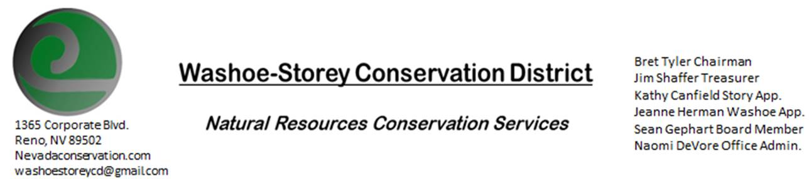
MINUTES 3/15/21
The Washoe-Storey Conservation District will hold a public meeting on Monday, March 15, 2021.
3:30p.m. The meeting will be held digitally on Google Meet- This is a Public Meeting
to participate please send an email RSVP to washoestoreycd@gmail.com by March 14.

The Conservation District will consider and act on the following items unless otherwise noted:
I. Call to Order:3:35
A. Introductions, Determination of Board Quorum, and Introduction of Guests: Naomi DeVore, Bret Tyler, Jessica Gwerder, Kathy Canfield, Victoria Cernoch, Sean Gephart, Paul Scott, Jim Shaffer
B. Determination of agenda order – Agenda items may be taken out of order or deleted for lack of time
II. Public Comments- There were No public comments.
III. District Projects – For Possible Action
A. Little Washoe Dam- Plan to meet with engineers and stakeholders for updates-We are looking for which day in the next month we can hold that meeting.
B. Washoe County Planning Reviews- No planning reviews yet this month, there were 7 from last month.
C. Storey County Projects – Kathy Canfield has been following bills as they go through the legislature. The Governor gave a news conference for the innovation zone and we will need more information to determine what the county’s official position will be. There is a potential grant to study long valley creek regarding downstream impacts, at the beginning phases of developing ideas for what exactly needs to be done.
D. Sage Grouse Projects- Sage Grouse Tags Update- Naomi is to send Jim the receipt for sage grouse packaging.
F. POOL/PACT applications- Cory Wadsworth-Jim believes it’s a good idea to move forward with this especially for liability if we are going to be delving further into weed control efforts, Naomi will fill out the application form and send it back to Cory to receive an estimate.

IV. External Agency Items and Reports – For Possible Action
- NRCS – Jessica Gwerder–Updates- the new covid policy has been no more than 25% capacity, meaning only 2 people can be at the field office at one time and they are closed to the public, meetings have been taking place in the field. The snow pack at 72% of average, precipitation was 58% , and reservoir storage to 39%.Overall water supply outlook have all been extremely low to overall averages.
State Technical Advisory meeting is coming up on March 22 at 9:30am. EQUIP and AMA deadlines will be assessed and ranked by the end of April.
B. NDCP -March Native Seed Forum-March 16-17- Naomi will try to find that meeting link to forward on.
C. DCNR – Melany Aten – Updates
D. WSCWMA- Sean Gephart- Discuss to vote on incorporating WSCWMA into WSCD-CWMA is very grateful to WSCD board for their help forming this non-profit organization. In the beginning of this process, Sean was working for the Ag department and his job was to form CWMAs. They are so far not very far along in the process of becoming a recognized non-profit. They have been paying for Zoom services and a p.o. box and so far have $1106.75 remaining, they do not want to run out of funds before they achieve non profit status since that status will allow them to apply for grants. They want to become a committee of WSCD in order to use our non-profit status and duns number in order to apply for grants. Bret wants the CWMA to be able to stand on it’s own long term, but this kind of help could be offered on a case-by-case basis to get the ball rolling. Jim adds that if the CWMA applied for a grant, and WSCD offered to loan matching funds, the CWMA would need to repay those funds. CWMA would also need to handle all their own paperwork if they become a committee of the WSCD, their paperwork would not be done WSCD staff. Kathy states that the CWMA shouldn’t be able to apply for grants without proposing these grants to the board for approval, but believes that the CWMA would be able to offer matching funds for grants in the form of labor and manpower and that the CWMA could be as helpful to the WSCD as we could be to them. Sean offers to return what remains of the money the WSCD donated to the CWMA in exchange for this help. We want to confer with Melany before we finalize any agreement, but believe this may be a viable mutually advantageous option to get to work combatting local weed infestations.
E. NVACD, Adjacent CD- -Comments on Statewide partnership with weed abatement groups & NVACD Website
F. New Partner Biologist- We met Victoria Cernoch
G. Steamboat Creek -The proposal to enclose sections of steamboat creek have been cancelled.

V. Internal District Issues – For Possible Action
A. Review, Amendment, and Approval of Minutes from previous meeting was tabled until the next meeting due to technical difficulties
B. Financial Reports -Treasurer Jim Shaffer
- Treasurer's Report- Balances and Financial Reports checking: 7,744.03/ Mitigation: $15,194.85/ jim proposed to move 2,000 to mitigation fund- bret makes the motion and Kathy seconds. Its approved unanimously.
• Employee Salary- Review and Approve Payment for Employee Hours- jim makes a motion, Kathy seconds, its approved unanimously.
C. Office Correspondence- email updates have been forwarded to board members throughout the month.

VI. Public Comments-Public comment will be allowed at the beginning, after each item on the agenda and prior to the adjournment of every meeting. Public comment may be limited to three (3) minutes per comment.
VII. Next Scheduled WSCD Board Meeting – (second Monday) April 12, 2021
VIII. Adjourn – Action 4:20

