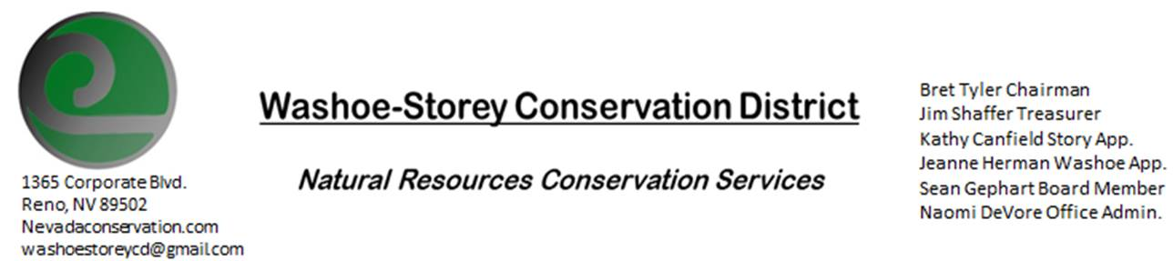
MINUTES 2/22/21
The Washoe-Storey Conservation District held a public meeting on Monday, February 22, 2021.
3:30p.m. The meeting was held digitally on Google Meet- This is a Public Meeting
to participate please send an email RSVP to washoestoreycd@gmail.com at least one day prior to the meeting.

The Conservation District will consider and act on the following items unless otherwise noted:
I. Call to Order 3:40p.m.
A. Introductions, Determination of Board Quorum, and Introduction of Guests:
Naomi DeVore, Cory Wadsworth, Paul Scott, Melany Aten, Victoria Cernoch, Jim Shaffer, Sean Gephart, Kathy Canfield, Trina Johnson
B. Determination of agenda order – Agenda items may be taken out of order until we have a quorum. 3 board members were present at the start of the meeting.
II. Public Comments-no public comments
III. District Projects – For Possible Action
A. Little Washoe Dam- We will want to hold a separate meeting in March to connect with engineers and stakeholders on this project, then draft an update to submit to DWR.
B. Washoe County Planning Reviews- this past month’s reviewed plans include Summit Church Cell Tower, Boulder Bay/Old Biltmore, and grading for a single family house with amendment to remove 30 ft easement for trail. We would like to keep 30ft trail easement.
C. Storey County Projects – Kathy Canfield-no updates
D. Sage Grouse Projects- Sage Grouse Tags Update- 6 boxes were purchased in February, 3,000 tags were boxed up. We will have to get more boxes in order to package the remaining tags for sale.
E. POOL/PACT- Cory Wadsworth works with Dolan Edwards as insurer for most rural entities. A 2018 program was put in place for insuring Association of Conservation Districts. Master policy allows any CD to join for coverage and benefits. WSCD did not apply in 2018, but are eligible. Pool would provide sponsorship, development, liability coverage, property coverage and protects individual board members from being sued up to $10million which includes environmental liability coverage in situations such as weed abatement even as 3rd party. They offer defense cost coverage as well as extra resources such as risk manager to advise projects. They also offer HR resources.
Jim Shaffer asks does this include staff/directors/officers on workers cost coverage, which it does.
We would need to apply in order to determine the annual cost of such coverage.

IV. External Agency Items and Reports – For Possible Action
- NRCS – Trina Johnson filled in for Jessica Gwerder. Covid-wise they are at phase 0 in Minden, only 1 person at field office at a time. She provides an Update on water supply outlook, river is at 81%- below average precipitation (62% of average). They received 4 applications in Washoe county (none of which were for high tunnels), 17 total in Nevada, 4 in California.
Upcoming ranking assessment- April 30. $362,000 for fund pool from Minden. There are possible additional applications. There have been 0 applications so far for conservation stewardship- deadline to be announced soon.
B. NDCP -March Native Seed Forum will take place March 16-17
C. DCNR – Melany Aten – State Conservation Commission meeting will take place digitally March 12, see agenda this week for legislative and budget issues, where cuts will be, and develop feedback for legislation.
-CD volunteer update to send out regular legislative updates on bills that affect resource concerns monthly to create partnerships and large grants with other conservation districts
D. WSCWMA- Sean Gephart- Discuss to vote on incorporating WSCWMA into WSCD-
Sean is now president of CWMA as of January. WSCD gave $2000 to start up left with $1,076 at the time of February meeting. Sean expressed his concern that the group will run out of funds before they are able to become a recognized non-profit which would enable them to apply for grants.
WSCWMA at this time has a president, vice president, secretary, 2 board members, no treasurer- had about 25 participants in their last meeting.
Melany makes a suggestion that CWMA could become a committee under WSCD- the groups could host meetings together with a break followed by CWMA committee meeting. A currently elected supervisor (in this case would be Sean) would have to be on the committee.
Sean expresses that CWMA could be doubling the workload separately when we could streamline our processes.
Jim asks who would be writing grants for CWMA, somehow there would have to be clear/ financial separation. CWMA’s goal should still be to become a recognized nonprofit. This agenda item is tabled in order to include WSCD chairman Bret Tyler into the conversation. Other members of the CWMA will also be included In our March 15 board meeting.
F. New Partner Biologist- Victoria Cernoch- We have Tori on the line though she is experiencing technical difficulties with her microphone volume, we hope to get to know her better during upcoming meetings.
G. Steamboat Creek – There was a public comment period regarding a proposal to contain sections of Steamboat creek within a pipeline, this project is currently on hold through NRCS.

V. Internal District Issues – For Possible Action
A. Review, Amendment, and Approval of Minutes from previous meeting-Kathy makes a motion to approve the minutes with her corrections, Sean seconds this motion and it passes unanimously.
B. Financial Reports -Treasurer Jim Shaffer
- Treasurer's Report- Balances and Financial Reports- $3949 in checking account, received $4000 from state leaving our checking account balance at $7,949. After that we updated our website domain for 2 years and purchased boxes to package sage grouse tags for sale. Mitigation balance is $15,179.85
- Financial report approved- motion by Jim, seconded by Sean.
• Employee Salary- Review and Approve Payment for Employee Hours-Jim makes a motion to approve January staff hours, and Kathy seconds.
C. Office Correspondence- Email Updates

VI. Public Comments-Public comment will be allowed at the beginning, after each item on the agenda and prior to the adjournment of every meeting. Public comment may be limited to three (3) minutes per comment.
VII. Next Scheduled WSCD Board Meeting – March 15, 2021(2nd Monday)
VIII. Adjourn – Action

