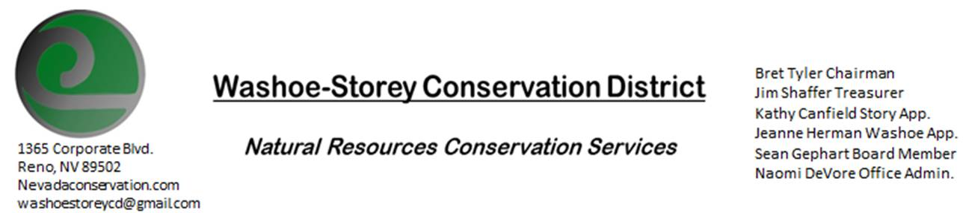
AGENDA 7/12/21
The Washoe-Storey Conservation District will hold a public meeting on Monday, July 12, 2021.
3:30p.m. The meeting will be held digitally on Google Meet- This is a Public Meeting
to participate please send an email RSVP to washoestoreycd@gmail.com by July 11.

The Conservation District will consider and act on the following items unless otherwise noted:
I. Call to Order
A. Introductions, Determination of Board Quorum, and Introduction of Guests
B. Determination of agenda order – Agenda items may be taken out of order or deleted for lack of time

II. Public Comments-Public comment will be allowed at the beginning, after each item on the agenda and prior to the adjournment of every meeting. Public comment may be limited to three (3) minutes per comment.
III. District Projects – For Possible Action
A. Little Washoe Dam- Review progress of engineering plans and stakeholders from recent discussions and the next steps in meeting with Big Ditch Co. to move forward with dam restoration.
B. Washoe County Planning Reviews- Updates
C. Storey County Projects – Kathy Canfield-Updates
D. Sage Grouse Projects- Updates
IV. External Agency Items and Reports – For Possible Action
A. NRCS – Jessica Gwerder–Updates
B. DCNR – Melany Aten – Updates
C. WSCWMA- Sean Gephart- Updates
D. NVACD, Adjacent CD- Updates
E. Partner Biologist- Victoria Cernoch
V. Internal District Issues – For Possible Action
A. Review, Amendment, and Approval of Minutes from previous meeting-
B. Financial Reports -Treasurer Jim Shaffer
- Treasurer's Report- Balances and Financial Reports
• Employee Salary- Review and Approve Payment for Employee Hours & Mileage
D. Office Correspondence-Our website NEVADACONSERVATION.COM has been restored

VI. Public Comments-Public comment will be allowed at the beginning, after each item on the agenda and prior to the adjournment of every meeting. Public comment may be limited to three (3) minutes per comment.
VII. Next Scheduled WSCD Board Meeting – (second Monday) August 9, 2021
VIII. Adjourn – Action

