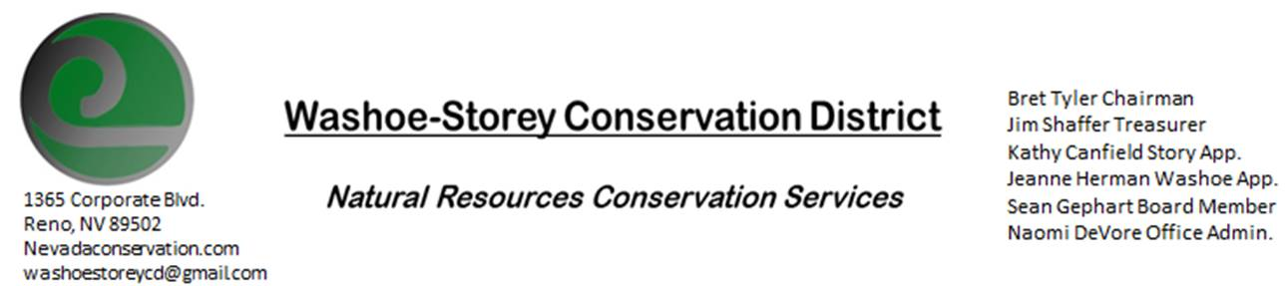
AGENDA 8/09/21
The Washoe-Storey Conservation District will hold a public meeting on Monday, August 9, 2021.
3:30p.m. The meeting will be held digitally on Google Meet- This is a Public Meeting
to participate please send an email RSVP to washoestoreycd@gmail.com by August 8.

We are looking forward to meeting in person again soon, At this time
The NRCS office where we used to hold our meetings is still closed. We are looking for alternatives.

The Conservation District will consider and act on the following items unless otherwise noted:
I. Call to Order
A. Introductions, Determination of Board Quorum, and Introduction of Guests
B. Determination of agenda order – Agenda items may be taken out of order or deleted for lack of time

II. Public Comments-Public comment will be allowed at the beginning, after each item on the agenda and prior to the adjournment of every meeting. Public comment may be limited to three (3) minutes per comment.
III. District Projects – For Possible Action
A. Little Washoe Dam- Review next steps in meeting with Big Ditch Co. in order to move forward with dam restoration.
B. Washoe County Planning Reviews- Updates
C. Storey County Projects – Rainbow Bend Weed Abatement project
D. Sage Grouse Projects- Updates
IV. External Agency Items and Reports – For Possible Action
A. NRCS – Jessica Gwerder– Updates
B. DCNR – Melany Aten – Updates
C. WSCWMA- Sean Gephart- Updates
D. NVACD, Adjacent CD- Updates
E. Partner Biologist- Victoria Cernoch
F. Truckee Meadows Regional Planning Agency- Kathy Canfield- Updates
V. Internal District Issues – For Possible Action
A. Review, Amendment, and Approval of Minutes from previous meetings-
B. Financial Reports -Treasurer Jim Shaffer
- Treasurer's Report- Balances and Financial Reports
- Review Annual Budget due September 30
• Employee Salary- Review and Approve Payment for Employee Hours
D. Office Correspondence- Updates

VI. Public Comments-Public comment will be allowed at the beginning, after each item on the agenda and prior to the adjournment of every meeting. Public comment may be limited to three (3) minutes per comment.
VII. Next Scheduled WSCD Board Meeting – (second Monday) September 13, 2021
VIII. Adjourn – Action

