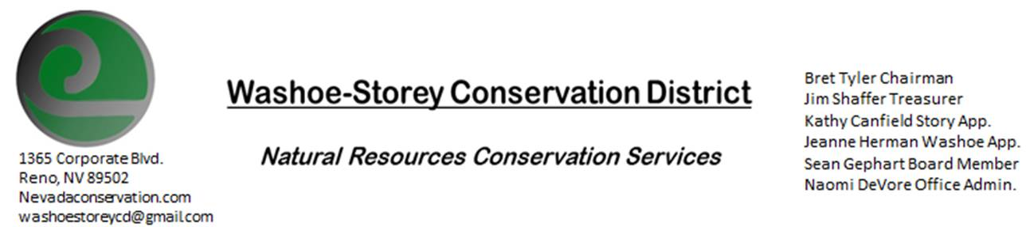
AGENDA 6/14/21
The Washoe-Storey Conservation District will hold a public meeting on Monday, June 14, 2021.
3:30p.m. The meeting will be held digitally on Google Meet- This is a Public Meeting
to participate please send an email RSVP to washoestoreycd@gmail.com by June 13.

We are looking forward to meeting in person again soon, At this time
The NRCS office where we used to hold our meetings is still closed. We are looking for alternatives.

The Conservation District will consider and act on the following items unless otherwise noted:
I. Call to Order
A. Introductions, Determination of Board Quorum, and Introduction of Guests
B. Determination of agenda order – Agenda items may be taken out of order or deleted for lack of time

II. Public Comments-Public comment will be allowed at the beginning, after each item on the agenda and prior to the adjournment of every meeting. Public comment may be limited to three (3) minutes per comment.
III. District Projects – For Possible Action
A. Little Washoe Dam- Review progress of engineering plans and stakeholders from recent discussions and the next steps in meeting with Big Ditch Co. to move forward with dam restoration.
B. Washoe County Planning Reviews- Updates
C. Storey County Projects – Kathy Canfield-Updates
D. Sage Grouse Projects- Potential threat to sage grouse habitat caused by proposed lithium mine at Thacker Pass in Humboldt County
IV. External Agency Items and Reports – For Possible Action
A. NRCS – Jessica Gwerder–Updates
B. DCNR – Melany Aten – Updates
C. WSCWMA- Sean Gephart- Updates
D. NVACD, Adjacent CD- Updates
E. Partner Biologist- Victoria Cernoch
V. Internal District Issues – For Possible Action
A. Review, Amendment, and Approval of Minutes from previous meeting-
B. Financial Reports -Treasurer Jim Shaffer
- Treasurer's Report- Balances and Financial Reports
• Employee Salary- Review and Approve Payment for Employee Hours
D. Office Correspondence-Website has been down, we are in the process of restoring it.
To contact us- reach out to washoestoreycd@gmail.com or 775 722 6302

VI. Public Comments-Public comment will be allowed at the beginning, after each item on the agenda and prior to the adjournment of every meeting. Public comment may be limited to three (3) minutes per comment.
VII. Next Scheduled WSCD Board Meeting – (second Monday) July 12, 2021
VIII. Adjourn – Action

