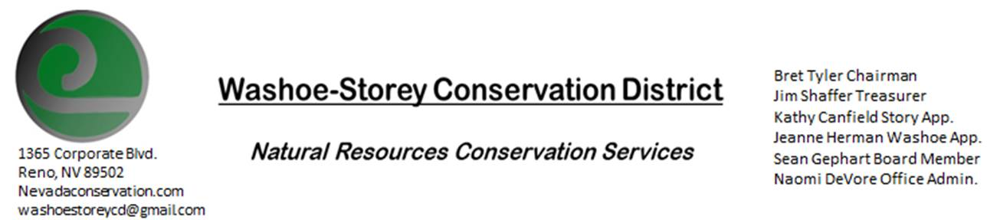
AGENDA 6/21/21
The Washoe-Storey Conservation District will hold a public meeting on Monday, June 21, 2021.
3:30p.m. The meeting will be held digitally on Google Meet- This is a Public Meeting
to participate please send an email RSVP to washoestoreycd@gmail.com by June 20.

The Conservation District will consider and act on the following items unless otherwise noted:
I. Call to Order
A. Introductions, Determination of Board Quorum, and Introduction of Guests
B. Determination of agenda order – Agenda items may be taken out of order or deleted for lack of time

II. Public Comments-Public comment will be allowed at the beginning, after each item on the agenda and prior to the adjournment of every meeting. Public comment may be limited to three (3) minutes per comment.
III. Internal District Issues- For Possible Action
- . Financial Report- Jim Shaffer
A. How much money was allocated to WSCD for the fiscal year July 1, 2020-June 30, 2021
B. How much money has been spent during the fiscal year July 1, 2020- June 30, 2021
C. What would be the most effective way to invest our remaining money to progress WSCD goals and prepare for upcoming projects.
D. Prepare and approve a budget plan to spend the remaining balance before June 30, 2021

IV. Public Comments-Public comment will be allowed at the beginning, after each item on the agenda and prior to the adjournment of every meeting. Public comment may be limited to three (3) minutes per comment.
V. Next Scheduled WSCD Board Meeting – (second Monday) July 12, 2021 [This meeting will be held both in-person and digitally via Google Meet- Meeting Address TBA]
VI. Adjourn – Action

