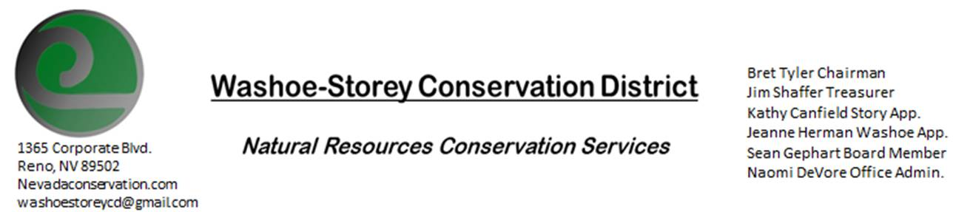
MINUTES 7/12/21
The Washoe-Storey Conservation District held a public meeting on Monday, July 12, 2021.
3:30p.m. The meeting will be held digitally on Google Meet- This is a Public Meeting.

The Conservation District will consider and act on the following items unless otherwise noted:
I. Call to Order
A. Introductions, Determination of Board Quorum, and Introduction of Guests: Bret Tyler, Naomi DeVore, Jim Shaffer, Kathy Canfield,Davie Phillips and Denise Hilton from Rainbow Bend in Lockwood,
B. Determination of agenda order – Agenda items may be taken out of order or deleted for lack of time

II. Public Comments-Public comment will be allowed at the beginning, after each item on the agenda and prior to the adjournment of every meeting. Public comment may be limited to three (3) minutes per comment.
+ Davie Phillips and Denise Hilton are from Rainbow Bend HOA in Storey County and they are trying to eradicate poison hemlock near the Truckee River. The Hemlock area is largely on state property, which would mean that we would have to run it by them before we could go forward. We had spoken to Nevada Dept. of Forestry about this project last year and took a took a tour of the infested area led and mapped by Davie. We can offer help with herbicide as well as herbicide to manage whitetop in residential areas in Rainbow Bend, we would need to speak with Sean Gephart to acquire the herbicide and discuss application. We will speak with the necessary persons and begin working towards this immediately.
+Protests continue in Washoe County regarding the planned Lithium Mine at Thacker Pass.
III. District Projects – For Possible Action
A. Little Washoe Dam- We have yet to hear correspondence about a date to meet with Galena Ditch Company or Big Ditch Company regarding how they plan to move forward with the restoration.
B. Washoe County Planning Reviews- Jim Shaffer reviewed 1 project so far in July, and 8 projects in June; mostly small projects such as requests for accessory dwellings and small plot subdivisions.
C. Storey County Projects – Kathy Canfield- A study on the highlands wells was extended for another year to acquire more data.
D. Sage Grouse Projects- Packaging of Sage Grouse Tags continues, there is a potential buyer of these tags that contacted us from Northern Washoe County.
IV. External Agency Items and Reports – No Updates

V. Internal District Issues – For Possible Action
A. Review, Amendment, and Approval of Minutes from previous meeting- This agenda item is tabled until the next meeting.
B. Financial Reports -Treasurer Jim Shaffer
- Treasurer's Report- Balances and Financial Reports- Microsoft Office was updated for the WSCD computer. Both bank accounts have started charging $15 per month, it may be time to divest and join a different bank. Checking: $3,844.85, Mitigation: $17,104.85
• Employee Salary- Jim motions and Kathy seconds the motion for 15.5 employee hours.
D. Office Correspondence-Our website NEVADACONSERVATION.COM has been restored

VI. Public Comments-Public comment will be allowed at the beginning, after each item on the agenda and prior to the adjournment of every meeting. Public comment may be limited to three (3) minutes per comment.
VII. Next Scheduled WSCD Board Meeting – (second Monday) August 9, 2021
VIII. Adjourn – Action

