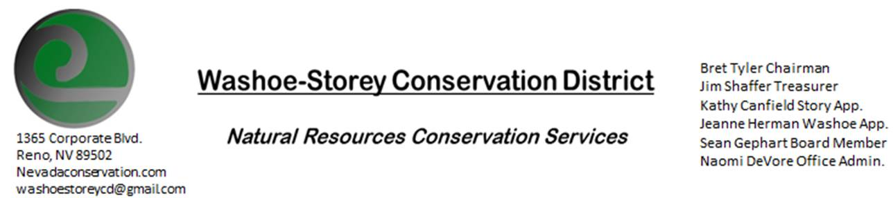
MINUTES 4/12/21
The Washoe-Storey Conservation District held a public meeting on Monday, April 12, 2021.
3:30p.m. The meeting will be held digitally on Google Meet- This is a Public Meeting

The Conservation District will consider and act on the following items unless otherwise noted:
I. Call to Order
A. Introductions, Determination of Board Quorum, and Introduction of Guests: Kathy Canfield, Bret Tyler, Naomi DeVore, Jim Shaffer, Sean Gephart, Paul Scott, Trina Johnson
B. Determination of agenda order – Agenda items may be taken out of order or deleted for lack of time
II. Public Comments- There were no public comments.
III. District Projects – For Possible Action
A. Little Washoe Dam- We will be attending a virtual meeting with JUB engineers and other stakeholders on April 29th at 2pm. We discussed in our September meeting that we could contribute $500 towards the initial planning phase.
B. Washoe County Planning Reviews- Jim Shaffer reviewed 11 projects over the past month. The 3 largest of those projects were 249 single family units on Village Parkway in Cold Springs, 24 homes on 75 acres on South Virginia- foothill removal of willow grove Jim recommended that they plant trees along that corridor with water induced wetland. The third project is a new reclaimed water tank- Jim asked them to tone down the color.
C. Storey County Projects – Kathy Canfield- received a letter from NVACD regarding dues. Tri-Center drainage facilities- people are wanting to construct a railroad on a drainage area, what are the impacts on that?
D. Sage Grouse Projects- Sage Grouse Tags Update- special labels have been made for the boxes and the boxes are at the office
F. POOL/PACT applications updates- Cory Wadsworth- no recent updates

IV. External Agency Items and Reports – For Possible Action
- NRCS – Trina Johnson- *Covid update- up to 4 people are now allowed at the Minden office with masks, visitors are allowed inside by appointment only.
*Nevada snowpack and precipitation levels are only at about 50% of average. Water storage is at 30% compared to 70% last year, it’s unlikely Tahoe will fill this year.
*Civil Rights Responsibilities- We discussed our civil rights responsibilities including reconnecting with underserved communities, an email was sent out to be signed and returned by all the board members.

B. NDCP -Updates
C. DCNR – Melany Aten – Updates
D. WSCWMA- Sean Gephart- We voted on and approved a motion to incorporating WSCWMA into WSCD. The WSCWMA will be able to work as a committee under WSCD to use WSCD’s nonprofit status to apply for grants. Jim made the motion to make a weed committee. We will take each financial situation on a case-by-case basis. Bret seconds the motion while Sean and Kathy approve of this motion, they abstain from voting. CWMA has already begun doing clean up events with community involvement and will continue to do so with support from WSCD.
E. NVACD, Adjacent CD- Updates- We received information regarding 2021 dues.
F. New Partner Biologist- Victoria Cernoch- no updates

V. Internal District Issues – For Possible Action
A. Review, Amendment, and Approval of Minutes from 2 previous meetings- Kathy makes a motion to approve the February and March minutes without corrections. The motion carries unanimously.
B. Financial Reports -Treasurer Jim Shaffer
- Treasurer's Report- Balances and Financial Reports – We received $4000 in state money, and placed $2000 of that into our mitigation fund. Our checking account balance is $5,241.53.
• Employee Salary- Review and Approve Payment for March Employee Hours- Jim makes the motion to approve 15 hours, Kathy seconds and the motion carries unanimously.
C. Office Correspondence- Email Updates

VI. Public Comments-Public comment will be allowed at the beginning, after each item on the agenda and prior to the adjournment of every meeting. Public comment may be limited to three (3) minutes per comment.
VII. Next Scheduled WSCD Board Meeting – (second Monday) May 10, 2021
VIII. Adjourn – Action

