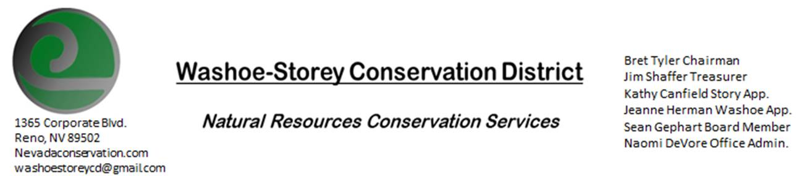
Minutes 5/10/21
The Washoe-Storey Conservation District held a public meeting on Monday, May 10, 2021.
3:30p.m. The meeting was hosted digitally on Google Meet- This is a Public Meeting
to participate please send an email RSVP to washoestoreycd@gmail.com.

The Conservation District will consider and act on the following items unless otherwise noted:
I. Call to Order
A. Introductions, Determination of Board Quorum, and Introduction of Guests: Naomi DeVore, Bret Tyler, Jim Shaffer, Kathy Canfield, Sean Gephart, Jeanne Herman, Trina Johnson
B. Determination of agenda order – Agenda items may be taken out of order or deleted for lack of time
II. Public Comments-Public comment will be allowed at the beginning, after each item on the agenda and prior to the adjournment of every meeting. Public comment may be limited to three (3) minutes per comment
III. District Projects – For Possible Action
A. Little Washoe Dam- Next meeting will be held between JUB Engineers and Stakeholders June 3 from 2-3pm. How will Big Ditch Company be responsible for the dam? We propose that they be responsible for long-term maintenance. They would need to be the ones to maintain it, otherwise they may need to relinquish control of the dam. NDOW has said that they would be willing to chip in to get the ball rolling. Some grant opportunities are not available since the dam is privately owned, if it were on state or federal land or if NDOW or state parks had water rights it would be more eligible for grant opportunities. The Big Ditch co. is responsible for the dam and has water rights, but the land itself where the dam resides has recently switched hands. Melany has reached out to the new landowner to let them know what’s been happening in regards to the dam restoration process.
B. Washoe County Planning Reviews- Jim Shaffer- There were 11 new projects in Washoe County in April. 2 new projects from Tahoe including concert planning at the junior college and an annual fashion show at the lake. Jim included stipulations regarding garbage and litter cleanup after the events. There is a new 42 lot subdivision going into Cold Springs, a 358-home subdivision by Bob Lissner in Red Rock, a new RV park in Wadsworth. The county is continuing send in all these plans for review shows that they have been valuing our (Jim Shaffer’s) input.
C. Storey County Projects – Kathy Canfield-No Updates
D. Sage Grouse Projects- Sage Grouse Tags- No Updates, Jim comments that we could attend farm or cattlemen’s events with an advertising booth with information about WSCD and Sage grouse tags for sale.

IV. External Agency Items and Reports – For Possible Action
A. NRCS – Trina Johnson–There are no new covid-related office updates. The NRCS office is operating with half capacity and guests only by appointment. The water outlook report is showing all below average at around 30%. Nevada EQIP applications have all been accessed and ranked. The Minden Work Group has $362,000 to distribute for 10 projects. The deadline to get these funded is August 1. 3 CSP applications have come out of the office so far. All civil rights forms from last month’s presentations have been signed by board members and returned.
B. NDCP -Updates
C. DCNR – Melany Aten – No Updates
D. WSCWMA- Sean Gephart- Sean has begun working for a new company- a global herbicide manufacturer that produces generics. He is starting to look at RFPs for Grants and lots of community outreach projects including Herbicide training by US forest service. Bret proposes we make plans for this summer for a river cleanup project in Storey County.
E. NVACD, Adjacent CD- Updates
F. Partner Biologist- Victoria Cernoch- Victoria was not at our meeting today though Sean commented that they are planning to meet.

V. Internal District Issues – For Possible Action
A. Review, Amendment, and Approval of Minutes from previous meeting- Kathy makes a motion to approve, Jim seconds, and the motion is approved unanimously.
B. Financial Reports -Treasurer Jim Shaffer
- Treasurer's Report- Balances and Financial Reports- We paid $600 in dues to NVACD. Our checking account has $4,401.53 and our Mitigation Account has $17, 134.85
• Employee Salary- Review and Approve Payment for Employee Hours- Approved Unanimously
C. Proposed Budget and Annual Work Plan due June 1st- Discuss and Approve Drafts- We reviewed our annual expenses and agreed on how the rest of our money should be spent. Most of our annual receipts are spent on office support and NVACD dues, we set aside moneys for Washoe Dam Engineering Plans and Truckee River Clean Up projects. Our annual plan was updated to reflect our new committee WSCWMA, and our work related to Little Washoe Dam.
D. Office Correspondence-Bret has been in communication with former board member Kevin Roukey about transferring our website hosting out of Kevin’s name.

VI. Public Comments-Public comment will be allowed at the beginning, after each item on the agenda and prior to the adjournment of every meeting. Public comment may be limited to three (3) minutes per comment.
VII. Next Scheduled WSCD Board Meeting – (second Monday) June 14, 2021
VIII. Adjourn – Action.

