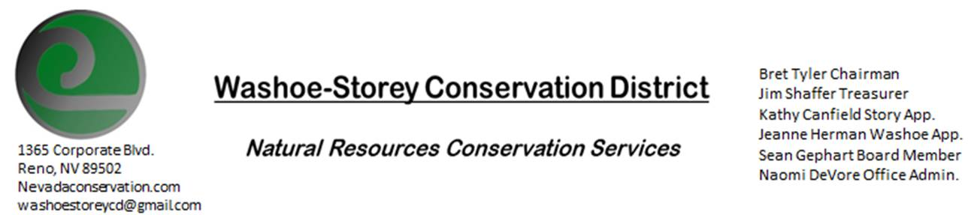
MINUTES 6/14/21
The Washoe-Storey Conservation District held a public meeting on Monday, June 14, 2021.
3:30p.m. The meeting was held digitally on Google Meet- This is a Public Meeting.

We are looking forward to meeting in person again soon, At this time
The NRCS office where we used to hold our meetings is still closed. We are looking for alternatives.

The Conservation District will consider and act on the following items unless otherwise noted:
I. Call to Order
A. Introductions, Determination of Board Quorum, and Introduction of Guests: Bret Tyler, Naomi DeVore, Sean Gephart, Melany Aten, Jim Shaffer, Jessica Gwerder,
B. Determination of agenda order – Agenda items may be taken out of order or deleted for lack of time

II. Public Comments-Public comment will be allowed at the beginning, after each item on the agenda and prior to the adjournment of every meeting. Public comment may be limited to three (3) minutes per comment.
III. District Projects – For Possible Action
A. Little Washoe Dam- Mel will get into contact with Galena Ditch Company and Big Ditch Company. We need participation and commitment from the ditch company owners and operators in order to make decisions and move forward. We have been committed to assist in the process of repairing the dam, but it is ultimately their responsibility. At this time, WSCD, NV state parks, DCNR, and NDOW have all committed time and money to the restoration of the dam but none of these entities hold water rights. We aim to meet with the Ditch Companies in June or July to discuss.
B. Washoe County Planning Reviews- Jim Shaffer- 4 projects were submitted in May, including community events, a grading project, and an equestrian center.
C. Storey County Projects – Kathy Canfield- An application has been put in for NV Uplands Solar in the middle of Storey County at the old Rocketdine facility. Transmission lines would connect the solar field to the Tricenter. The fire protection district received a grant from NV energy to protect powerlines, this will allow for county weed management and fuels reduction staff. There will be more staff than there has been in years past to work on removal of invasive whitetop in and around 6-mile Canyon.
TMWA diverted water to Truckee that wouldn’t meet quality drinking water standards, permitting has now begun to divert this water to the TriCenter to be used for cooling.

D. Sage Grouse Projects- Potential threat to sage grouse habitat caused by proposed lithium mine at Thacker Pass in Humboldt County. Indigenous communities especially have been protesting the project and the likely contamination of the area and it’s water. Melany reported that the mining company has been good to work with, and seems to want to do right by wildlife and have studied areas of impact and mitigation before moving forward. The specific project areas supposedly would not harm sage grouse.
Additional cardboard packaging for sage grouse tags has been delivered.
IV. External Agency Items and Reports – For Possible Action
A. NRCS – Jessica Gwerder–The NRCS in Minden is operating at 50% capacity with maximum possible telecommunication. EQUIP and AMA applications are in the pre-approval phase. There was not enough funds to grant all high tunnel applications.
B. DCNR – Melany Aten – The Program manager position has been vacant while Mel has been acting program manager, this position could now be replaced. She has said that she would not apply if the position requires to be based in Carson City. There is a possibility of there being a Western Staff Specialist. Additionally we discussed the ways that CD’s manage urban agriculture in western Nevada compared to producers in rural Nevada.
The State Conservation Commission meeting is coming up, keep an eye out for an agenda in July. The annual meeting for CD’s will be held in November. Our CD could seek grants and get matches from the new Water Runoff Initiative.
C. WSCWMA- Sean Gephart- The CWMA will return about $1000 to WSCD in August. $2,000 was initially given to get them started but the CWMA has been added to WSCD as a committee so the remaining dollars will be returned. They will be looking for grant opportunities through the Nevada Dept. of Wildlife.
Potential Projects-
The I-80 corridor near Cabella’s at Verdi has been invaded by yellow star thistle. We also discussed an idea to distribute herbicide to landowners along with informational booklets about application, then we could establish a follow-up process to ensure the weeds were eradicated.

V. Internal District Issues – For Possible Action
A. Review, Amendment, and Approval of Minutes from previous meeting- Kathy Canfield made a motion to approve the minutes and motion passed unanimously.
B. Financial Reports -Treasurer Jim Shaffer- Checking $4,214.00, Mitigation $17,119.00
- Treasurer's Report- Balances and Financial Reports- As we reach the end of the fiscal year, we discuss concern that we may not have spent our state money. This money, if it has not already been spent would need to be spent before the end of the month. We considered projects listed above in Section C. WSCWMA” We also considered the purchase of a GPS unit for weed mapping projects, purchasing seed or sage brush starts to donate, donating to a scholarship fund or to a local urban farm, as well as some necessary mileage payments for travel and updates for our office laptop . We begun to plan a special meeting before the end of the month to approve an expenditure plan. [In the days following this meeting, Jim Shaffer determined that we had in fact already spent the state-allocated money before the end of the fiscal year, so no special meeting was held]
• Employee Salary- Review and Approve Payment for 15 Employee Hours at $15/hr.
D. Office Correspondence-Website has been down, we are in the process of restoring it.
To contact us- reach out to washoestoreycd@gmail.com or 775 722 6302

VI. Public Comments-Public comment will be allowed at the beginning, after each item on the agenda and prior to the adjournment of every meeting. Public comment may be limited to three (3) minutes per comment.
VII. Next Scheduled WSCD Board Meeting – (second Monday) July 12, 2021
VIII. Adjourn – Action

