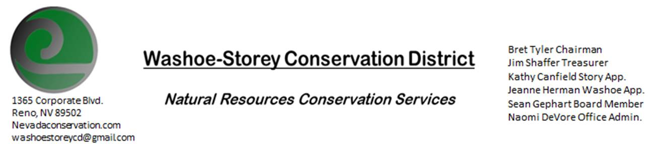
MINUTES 9/13/21
The Washoe-Storey Conservation District held a public meeting on Monday, September 13, 2021.
3:30p.m. The meeting will be held digitally on Google Meet- This is a Public Meeting
to participate please send an email RSVP to washoestoreycd@gmail.com

The Conservation District will consider and act on the following items unless otherwise noted:
I. Call to Order
A. Introductions, Determination of Board Quorum, and Introduction of Guests: Bret Tyler, Naomi DeVore, Kathy Canfield, Connie Lee, Jessica Gwerder, Sean Gephart, Melany Aten, Jim Shaffer, Victoria Cernoch
B. Determination of agenda order – Agenda items may be taken out of order or deleted for lack of time

II. Public Comments-Public comment will be allowed at the beginning, after each item on the agenda and prior to the adjournment of every meeting. Public comment may be limited to three (3) minutes per comment.
-Recent Wildfires near Lake Tahoe have caused significant disruption and destruction to our area: Bret’s family home did not burn in Myers though his sister has been working diligently to protect the space around the house as the fire approached; waiting on updates on how bad the damage is in that area. Christmas Valley is reportedly destroyed.
III. District Projects – For Possible Action
A. Little Washoe Dam- No updates/ NDOW would still like to move forward with this project…
B. Washoe County Planning Reviews- 6 small projects were reviewed this month: regarding an excavation to build a pond (20 feet deep), Jim suggested to put rocks around the edge 2 ft above and below the water line to prevent any persons or animals from falling in and being unable to get out again.
C. Storey County Projects – Rainbow Bend Weed Abatement project updates
D. Sage Grouse Projects- No Recent Updates
IV. External Agency Items and Reports – For Possible Action
A. NRCS – Jessica Gwerder– Plans for Local Work group meeting before December would need to have advertisements posted in RGJ- at least 45 days prior to the meeting in mid-December. Introduction of New Conservationist/ Rangeland Specialist Carson Hicks. State Employees are supposed to Self-Certify that they have been vaccinated against Covid 19. Updates on projects that have been funded and deferred.
B. DCNR – Melany Aten – CD Annual Plan and Budget are due September 30. Melany has been hired to the Staff Program Manager Position and will be staying in Winnemucca. A new Western Nevada staff specialist will be assigned to us.
C. WSCWMA- Sean Gephart- Brought on Connie Lee of NVACD/ Nevada Weed Management-
Meeting was cancelled, WSCWMA meetings WSCD meetings are planned to be held back to back to best join forces.
There will be an upcoming clean-up day hosted by KTMB at the river on September 25, with Sean to be the site lead. He also recently met with Piaute Tribe: Purple Loose Strife now reaches all the way down the Truckee.

Chairman Bret Tyler comments-We’d like to help Rainbow Bend HOA eliminate Poison Hemlock in Lockwood, Nevada. Sean can provide an aquatic approved hemlock herbicide to eliminate rosettes for next year. Kathy comments that we need someone from the state to approve our work on state land: Sean’s former position at the Department of Agriculture (State Noxious Weed Coordinator) has recently been filled, we’ll speak with this person to get approval for the project to move forward.

D. NVACD, Adjacent CD- Updates
E. Partner Biologist-Tori Cernoch – Will check in again about payment regarding taxidermy. Tori brought up the Interlocal Alliance between the CD and NDOW which sets a contract in place for projects in the next four years with an allowance of up to $50,000. The previous copy of this document has been sent to the board members and will appear in our next agenda. Bring project ideas
F. Truckee Meadows Regional Planning Agency- Kathy Canfield- No Updates
V. Internal District Issues – For Possible Action
A. Review, Amendment, and Approval of Minutes from previous meeting-Approved
B. Financial Reports -Treasurer Jim Shaffer- Kathy makes a motion to approve the Treasurer’s Report below
Treasurer's Report- Balances and Financial Reports-- Checking: $3,061.--, Mitigation: $17, 074.85
- Review to Approve Annual Budget due September 30-
  - Add all dates for previous years’ meetings (July 1, 2020-June 30, 2021) in Annual Plan, Ammend and Add Cooperative Weed Management as a committee to Conservation District, Update amounts in Annual Budget, Set Meeting Time for morning of 9/21/21 to approve these changes to submit.
• Employee Salary- Review and Approve Payment for Employee Hours- 13 Hours for August Approved
Item tabled for October meeting: Review budget to approve employee pay raise from $15 to $17
+ A Special Meeting will be hosted 9/21/21 to approve the Annual Planning Report and Annual Budget Report

VI. Public Comments-Public comment will be allowed at the beginning, after each item on the agenda and prior to the adjournment of every meeting. Public comment may be limited to three (3) minutes per comment.
VII. Next Scheduled WSCD Board Meeting – (last Monday October 25)
VIII. Adjourn – Action

