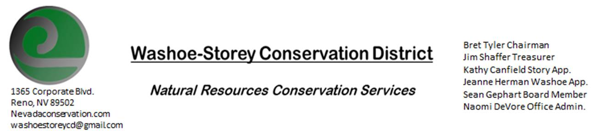
MINUTES 10/25/21
The Washoe-Storey Conservation District held a public meeting on Monday, October 25, 2021.
3:30p.m. The meeting will be held digitally on Google Meet- This is a Public Meeting
to participate please send an email RSVP to washoestoreycd@gmail.com by October 24.

We are looking forward to meeting in person again soon, At this time
The NRCS office where we used to hold our meetings is still closed. We are looking for alternatives.

The Conservation District will consider and act on the following items unless otherwise noted:
I. Call to Order
A. Introductions, Determination of Board Quorum, and Introduction of Guests: Sean Gephart, Kathy Canfield, Jim Shaffer, Bret Tyler, Naomi De Vore, Tori Cernoch, and Jessica Gwerder.
B. Determination of agenda order – We will start with Internal District Issues and approving this month’s financials. Jim makes the motion to change the order of the agenda, and Kathy seconds.

II. Public Comments-Public comment will be allowed at the beginning, after each item on the agenda and prior to the adjournment of every meeting. There were no public comments.
V. Internal District Issues – For Possible Action
A. Review, Amendment, and Approval of Minutes from previous meeting- Kathy makes motion to approve minutes for 9/13 with changes in names from Jim, Sean seconds the motion. Kathy makes a motion to approve the 9/21 minutes as written, Bret Seconds
B. Financial Reports -Treasurer Jim Shaffer
- Treasurer's Report- Balances and Financial Reports: Money was spent on our website ($8.71) and on employee salary. This leaves our balances at $2,842--(Checking) and $17,059.85 (Mitigation)
- • Employee Salary- Review and Approve Payment for Employee Hours, Review Budget to approve increase in employee salary: 18 employee hours are approved for September. Jim makes a motion to increase employee salary from $15/hour to $17/hour- Kathy seconds the motion.

III. District Projects – For Possible Action
A. Little Washoe Dam- No Updates regarding Big Ditch and Galena Ditch Companies. Due to recent rain- there is once again water running through the Dam.
B. Washoe County Planning Reviews- 12 small projects including master plan amendments were reviewed in September. One larger project is a 260-unit Senior Facility in Spanish Springs. For a commercial project in Mustang, NV Jim makes suggestions regarding effective revegetation, detention basins, and natural building color that complements the surrounding landscape. (Scott Bennett of S& B Engineers followed up)
C. Storey County Projects – Kathy comments on an RV park along I-80- regarding increased traffic and water rights (many of the parcels along the Truckee River do not have water rights) Rainbow Bend Weed Abatement project can move forward once we receive approval from the new Noxious Weed Coordinator at the Dept. of Agriculture Community Org Grant is available in Storey County- the deadline is November 5.
D. Sage Grouse Projects- No Recent Updates
IV. External Agency Items and Reports – For Possible Action
- NRCS – Jessica Gwerder– Upcoming application deadline is Nov. 19
Plans for Local Work group meeting on December 16 at 10am. Naomi and Jessica will work together to distribute the agenda, meeting link, and other advertisements. We will cohost with another Conservation District (Carson Valley), Jessica will give a presentation and Naomi will send out invitations to interested partners and local tribes.
B. DCNR – Melany Aten – No Updates
C. WSCWMA- Sean Gephart- Updates-State of NV has a Noxious weed prevention website- Sean and the rest of the board can make recommendations specific to Washoe County. This Wednesday there will be a NV Weed Management Meeting. WSCWMA plans to chime in on this meeting and will spread information about the Community Org Grant.

D. NVACD, Adjacent CD- No Updates
E. Partner Biologist- Victoria Cernoch- At the NV Weed Management Meeting, Tori plans to talk about Purple Loose Strife to gauge interest in treating this type of noxious weed along the river. We could apply for grants for removal projects- NDA has money for these types of projects- they could contract us to plan and organize volunteers for a clean-up event. NDEP also offers a 319 Grant for the clean water act every fall (specifically for any project that includes a rehab element.)
Review changes to approve updated Interlocal Agreement with NDOW at our next meeting. The new agreement should have some name changes, and an update of the scope of work NDOW would agree to- the agreement would last 4 years from the date approved and would allow spending up to $50,000- specifically calling out pinion and juniper treatment
F. Truckee Meadows Regional Planning Agency- Kathy Canfield- Kathy sent an email following up regarding Truckee Meadows Regional Planning Committee to find out what their planned timeline is- Jim and Sean to attend the next meeting whenever that is

VI. Public Comments-Public comment will be allowed at the beginning, after each item on the agenda and prior to the adjournment of every meeting. Public comment may be limited to three (3) minutes per comment. No public comments were given at this time
VII. Next Scheduled WSCD Board Meeting – December 8 at 3:30-We do not plan to host a meeting in November.
VIII. Adjourn – Action

