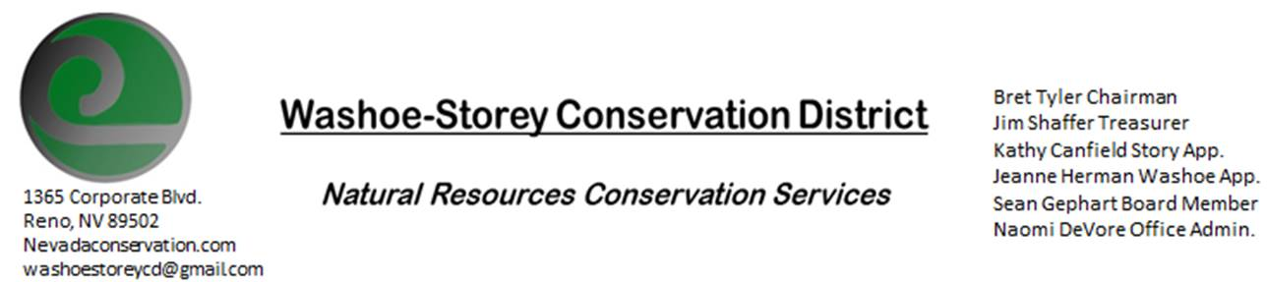
Minutes 12/8/21
The Washoe-Storey Conservation District held a public meeting on Wednesday Dec. 8, 2021.
3:30p.m. The meeting will be held digitally on Google Meet- This is a Public Meeting
to participate please send an email RSVP to washoestoreycd@gmail.com by December 7.

The Conservation District will consider and act on the following items unless otherwise noted:
I. Call to Order
A. Introductions, Determination of Board Quorum, and Introduction of Guests: Kathy Canfield, Sean Gephart, Naomi DeVore, Bret
B. Determination of agenda order – Agenda items may be taken out of order or deleted for lack of time

II. Public Comments-Public comment will be allowed at the beginning, after each item on the agenda and prior to the adjournment of every meeting. Public comment may be limited to three (3) minutes per comment.
III. District Projects – For Possible Action
A. Little Washoe Dam- NDOW and Louie Damonte began working on a diversion dam next to Washoe lake- this progress will hopefully prompt momentum to continue working together towards next projects.
B. Washoe County Planning Reviews- 11 projects were reviewed from Washoe County including a grading project for a new pasture and an amendment to a pump house from Truckee Meadows Water Authority
C. Storey County Projects – No Updates

D. Weed Abatement Projects- A $10,000 grant is available for community-wide projects on state land. Weed abatement projects and projects related to defensible space would be realistic for this grant which we could apply for during Fall 2022
E. Add to our agenda for next month- Create a list of attainable goals and actions for January 2022- January 2023 to take WSCD out of the meeting space and into the field.

IV. External Agency Items and Reports – For Possible Action
A. NRCS – Jessica Gwerder–Upcoming Local Work Group Meeting will take place Dec. 16 at 10a.m. in partnership with Carson Valley Conservation District. In this meeting, we will prioritize resource concerns (ex. Water quantity and quality) for our district and for individuals in our areas. A template has been sent out with the meeting agenda to report our top priorities: these priorities are directly tied to how NRCS distributes funding for projects.
B. DCNR – Melany Aten – WSCD is in good standing and will receive full funding of $4,000+ for the upcoming year. We can also expect new staff to join after the new year.
C. WSCWMA- Sean Gephart- Sean spoke with the Truckee Meadows Planning Commission if WSCD wanted to agree to a new development project. Updates on marshland contaminated with mercury where new developments are being built (near Veterans parkway.)
NV Weed Mgmt Association & Nevada Landscape Association are hosting an event on March 3: Pesticide Workshop at Reno/Sparks Convention Center. WSCD could potentially have a booth
D. NVACD, Adjacent CD- No Updates
E. Partner Biologist- Victoria Cernoch- The interlocal agreement has been submitted, the board will be notified when this agreement officially goes through. Reimbursement for the Sage Grouse taxidermy is in our mailbox at NRCS.
F. Truckee Meadows Regional Planning Agency- Kathy Canfield- Updates will come in the new year.
V. Internal District Issues – For Possible Action
A. Review, Amendment, and Approval of Minutes from previous meeting- Kathy Canfield makes a motion to approve the minutes from our last meeting, Jim Shaffer seconds the motion, and the motion carries unanimously.
B. Financial Reports -Treasurer Jim Shaffer
- Treasurer's Report- Balances and Financial Reports: Kathy Canfield makes a motion to approve the following financial report, Jim Shaffer Seconds the motion and the motion carries unanimously.
  - Mitigation Account $17, 029. 85, Checking Account $2, 512. 58
• Employee Salary- 12 Employee hours are approved at $17 per hour.
D. Office Updates- Our physical office at NRCS will no longer be available and we will need to find an alternative location.

VI. Public Comments-Public comment will be allowed at the beginning, after each item on the agenda and prior to the adjournment of every meeting. Public comment may be limited to three (3) minutes per comment.
VII. Next Scheduled WSCD Board Meeting – (second Monday) January 10
VIII. Adjourn – Action

