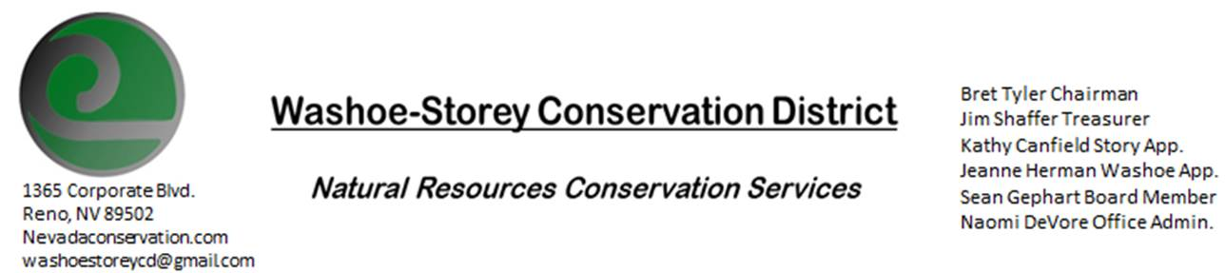
Special Meeting - AGENDA 9/21/21
The Washoe-Storey Conservation District will hold a public meeting on Tuesday, September 21, 2021.
at 9.00 a.m. The meeting will be held digitally on Google Meet- This is a Public Meeting
to participate please send an email RSVP to washoestoreycd@gmail.com by September 20.

The Conservation District will consider and act on the following items unless otherwise noted:

I. Call to Order
A. Introductions, Determination of Board Quorum, and Introduction of Guests: Bret Tyler, Naomi DeVore, Kathy Canfield, Jim Shaffer
B. Determination of agenda order – Agenda items may be taken out of order or deleted for lack of time

II. Public Comments-Public comment will be allowed at the beginning, after each item on the agenda and prior to the adjournment of every meeting. Public comment may be limited to three (3) minutes per comment.

III. Review and Approve Annual Plan July 1, 2020 – June 30, 2021
Jim Shaffer makes a motion to approve Annual Plan as presented, Kathy Canfield seconds the motion and the motion carries unanimously.

VI. Review and Approve Year End Financial Documents July 1, 2020- June 30, 2021
Bret Tyler makes a motion to approve the financial figures as presented by Treasurer Jim Shaffer, Jim Shaffer seconds the motion and the motion carries unanimously. Naomi DeVore will format the document to submit.

V. Review Interlocal Agreement-
A copy of the Interlocal Agreement has been sent to all board members. We will vote to approve the Interlocal Agreement with NDOW during our October 25 Meeting.

VI. Public Comments-Public comment will be allowed at the beginning, after each item on the agenda and prior to the adjournment of every meeting. Public comment may be limited to three (3) minutes per comment. No public comment.
VII. Next Scheduled WSCD Board Meeting – October 25 at 3:30pm
VIII. Adjourn – Action

