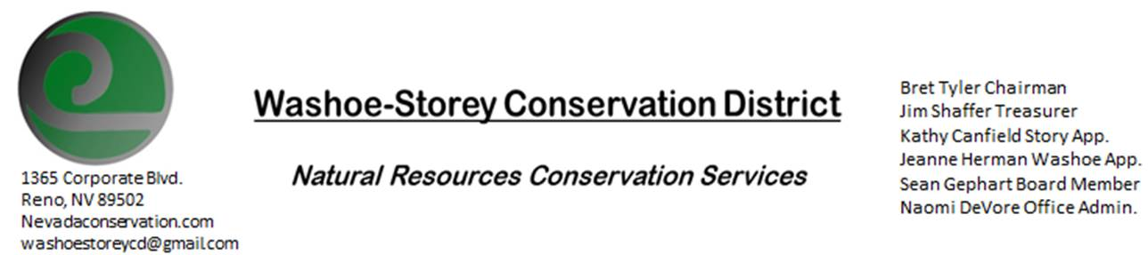
AGENDA 5/9/22
The Washoe-Storey Conservation District will hold a Public Meeting on
Monday, May 9, 2022. 3:30p.m.
The meeting will be held digitally on Google Meet and in person at the Reno Downtown Library 301 S. Center St.
to participate through Google Meet please send an email RSVP to washoestoreycd@gmail.com by May 8.
The Conservation District will consider and act on the following items unless otherwise noted:
I. Call to Order
A. Introductions, Determination of Board Quorum, and Introduction of Guests
B. Determination of agenda order – Agenda items may be taken out of order or deleted for lack of time

II. Public Comments-Public comment will be allowed at the beginning, after each item on the agenda and prior to the adjournment of every meeting. Public comment may be limited to three (3) minutes per comment.
III. District Projects – For Possible Action
A. Little Washoe Dam- Updates
B. Washoe County Planning Reviews- Updates
C. Storey County Projects – Finalize Grant for Storey County Weed Abatement
D. Upcoming Outreach and Community Projects – Potential Projects and Updates
E. Sage Grouse Projects- Sale of Sage Grouse Tags to NDOW

IV. External Agency Items and Reports – For Possible Action
A. NRCS – Jessica Gwerder– Local Work Group Meeting in August and other Updates
B. DCNR – Melany Aten – Proposed Work Plan is due June 1, 2022
C. Sean Gephart- Updates
D. NVACD, Adjacent CD- Updates
E. NDOW- Partner Biologist- Victoria Cernoch- WSCD/NDOW Interlocal Agreement Potential Projects
F. Truckee Meadows Regional Planning Agency- Updates
V. Internal District Issues – For Possible Action
A. Review, Amendment, and Approval of Minutes from previous meeting-
B. Financial Reports -Treasurer Jim Shaffer
- Treasurer's Report- Balances and Financial Reports
• Employee Salary- Review and Approve Payment for Employee Hours for April
C. Review, Update and Approve Proposed Work Plan by June 1
D. Office Updates

VI. Public Comments-Public comment will be allowed at the beginning, after each item on the agenda and prior to the adjournment of every meeting. Public comment may be limited to three (3) minutes per comment.
VII. Next Scheduled WSCD Board Meeting – (second Monday) June 13, 2022
VIII. Adjourn – Action

