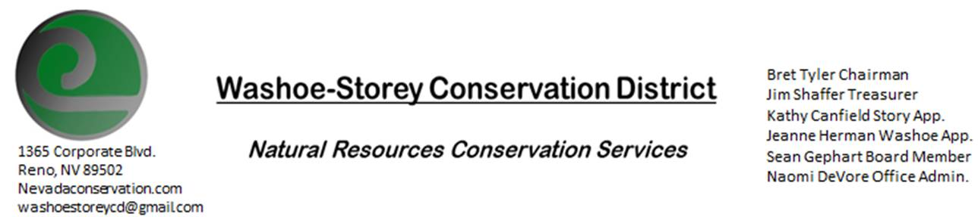
MINUTES 2/7/22
The Washoe-Storey Conservation District held a public meeting on Monday, Feb. 7, 2022.
3:30p.m. The meeting will be held digitally on Google Meet- This is a Public Meeting
to participate please send an email RSVP to washoestoreycd@gmail.com by February 6
The Conservation District will consider and act on the following items unless otherwise noted:
I. Call to Order
A. Introductions, Determination of Board Quorum, and Introduction of Guests: Naomi DeVore, Bret Tyler, Jim Shaffer, Kathy Canfield, Sean Gephart
B. Determination of agenda order – Agenda items may be taken out of order or deleted for lack of time

II. Public Comments-Public comment will be allowed at the beginning, after each item on the agenda and prior to the adjournment of every meeting. Public comment may be limited to three (3) minutes per comment.
III. District Projects – For Possible Action
- Begin Action on Goals for 2022
    - Draft language for a plan to combat noxious weeds
    - Begin holding meetings in person, we can reserve a meeting room at the downtown library in Reno.
    - Get in contact with Lockwood community corporation and rainbow bend HOA (the HOA meets the last Tuesday of each month), and canyon GID to get community members involved and let them know we have funding and plan to move forward with the noxious weed removal project along the river.
B. Little Washoe Dam- No Updates at this time.
C. Washoe County Planning Reviews- 11 projects were reviewed for this month including new condo development, new apartments in Sun Valley and Palamino Valley, and a grading project in Southwest Reno, and a project at Mount Rose Highway. Jim made a recommendation for replacing trees, suggesting that 2 trees be replanted for each 1 that is removed to ensure regrowth. Bret comments that 3 to 1 might be better to ensure that at least the same number of trees grow to maturity.
D. Storey County Projects – Rainbow Bend Weed Abatement Project Updates- We have received our state funding and will additionally be applying for a grant in Storey County to pay for this Weed abatement project. Sean has whitetop herbicide available to donate toward this project.
New Solar project in Storey County and a new road for a pipeline from Washoe County through Storey County.
E. Sage Grouse Projects- We have sage grouse tags available for purchase. No recent updates at this time.

IV. External Agency Items and Reports – For Possible Action
A. NRCS – Jessica Gwerder– No Updates
B. DCNR – Melany Aten – Updates
C. WSCWMA- Sean Gephart- The CWMA has not been active currently. Nevada Landscape Association is coming up on March 3. Sean will send over a presentation on our area’s noxious weeds.
D. NVACD, Adjacent CD- No Updates
E. NDOW- Partner Biologist- Victoria Cernoch- WSCD/NDOW Interlocal Agreement
F. Truckee Meadows Regional Planning Agency- No Updates
V. Internal District Issues – For Possible Action
A. Review, Amendment, and Approval of Minutes from previous meeting- Approved with minor changes including spelling of “Biltmore”
B. Financial Reports -Treasurer Jim Shaffer:
- Treasurer's Report- Balances and Financial Reports: Our annual funding came in for $4,000
- Checking Account Balance: $2,261.16, Mitigation Fund Balance: $19,271.61
  - $182 was approved to pay for 1 year of a P.O. box. Bret made the motion and it was approved unanimously.

• Employee Salary- Kathy makes a motion and it is unanimously approved 15 hours for January, a motion was made to pay Steven Burton up to $150 to help with IT issues.
D. Office Updates - We can hold our upcoming meeting at the downtown public library

VI. Public Comments-Public comment will be allowed at the beginning, after each item on the agenda and prior to the adjournment of every meeting. Public comment may be limited to three (3) minutes per comment.
VII. Next Scheduled WSCD Board Meeting – (second Monday) March 14
VIII. Adjourn – Action

