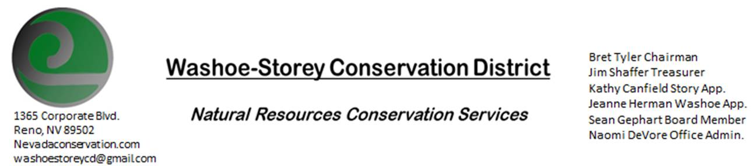
MINUTES 3/14/22
The Washoe-Storey Conservation District held a Public Meeting on
Monday, March 14, 2022. 3:30p.m.
The meeting was held digitally on Google Meet and in person at the Reno Downtown Library 301 S. Center St.
to participate through Google Meet please send an email RSVP to washoestoreycd@gmail.com.

The Conservation District will consider and act on the following items unless otherwise noted:
I. Call to Order
A. Introductions, Determination of Board Quorum, and Introduction of Guests:
Tori Cernoch, Sean Gephart, Bret Tyler and Naomi DeVore met at the Reno Downtown Library. Jim Shaffer, Kathy Canfield, and Jessica Gwerder joined us digitally through Google Meet.
B. Determination of agenda order – Agenda items may be taken out of order or deleted for lack of time

II. Public Comments-Public comment will be allowed at the beginning, after each item on the agenda and prior to the adjournment of every meeting. Public comment may be limited to three (3) minutes per comment. No public comments
III. District Projects – For Possible Action
A. Little Washoe Dam- No Updates
B. Washoe County Planning Reviews- 9 projects were submitted in February including grading projects, housing projects, and a project at Hunter Creek. 11 projects were submitted for review in March- updates on these projects will be reported during next month’s meeting
C. Storey County Projects – Rainbow Bend Weed Abatement Project Updates – Communications were initiated with Rainbow Bend’s HOA and Canyon General Improvement District in Lockwood, NV near the project site. The grant for this project will be written and submitted by WSCD as a community project with involvement from local residents from both Rainbow Bend and Lockwood in Storey County. This project will benefit the local community and recreation and decrease downriver pollen transportation. We want to encourage inclusivity and volunteering from residents and discuss phrasing the grant as The Happy Valley Collective
Naomi will write the grant with support from board members Bret Tyler, Jim Shaffer, and Sean Gephart and Kathy Canfield will review the final draft before we turn it in. The budget would need to be sent by July, the grant should be turned in as soon as possible. Supplies that we would need to purchase could include rakes, trimmers, tools, bags, herbicide, gloves. After the project is completed, these tools could be openly available at the senior center for use and maintenance.
D. Sage Grouse Projects- Updates – There are sage grouse grants available that we could apply for in partnership with other CDs such as VYA Conservation District who we partnered with in the past. We have sage grouse tags available for purchase.

IV. External Agency Items and Reports – For Possible Action
- NRCS – Jessica Gwerder– Office updates includes supervisors returning to work at the office on April 18 and non-supervisors would return by May. Our Local Work Group meeting should be held in August this year but may need to remain virtual. The Minden Grant Pool has funding available.
10 EQIP applications
5 AMA- 5/6 in Washoe County high tunnels
CSP deadline is April 8
EQIP-CIC is a 5 year contract focused on certain resource concerns NEW
Jessica poses a question to Jim Shaffer regarding Washoe County permitting a 280 square foot high tunnel:
B. DCNR – Melany Aten – No Updates
C. Sean Gephart- Sean attended the March 3 Landscape Association Meeting as a NV Weed Mgmt Association Affiliate. He’s currently with the Division of Forestry working on fuel reduction and weed reduction around NV Energy power lines. Sean would like to donate boxed dry herbicide for use against Whitetop in Storey County.
Sean is reaching out to other environmental groups to partner with to produce the noxious weeds pamphlets we’ve discussed designing. The CWMA committee has not been meeting lately; it may be redundant since WSCD as a board has been working on weed abatement projects themselves.
E. NDOW- Partner Biologist- Victoria Cernoch- WSCD/NDOW Interlocal Agreement is near completion and we will be able to move forward with a project under that agreement. Department of Agriculture is looking for collaborators for a project to remove purple loosestrife.
F. Other Updates from Local Groups: One Truckee River has been working towards hosting a fundraiser near Brodhead Memorial Park. KTMB will be hosting spring clean up days which we would like to sponsor. This summer we could sponsor scholarships for 3 kids to attend Range Camp June 19-25 Northeast of McGill. Applications are open, Bret plans to reconnect with them to offer sponsorships.
F. Truckee Meadows Regional Planning Agency- No Updates
V. Internal District Issues – For Possible Action
A. Review, Amendment, and Approval of Minutes from previous meeting- Tabled until the next meeting.
B. Financial Reports -Treasurer Jim Shaffer
- Treasurer's Report- Balances and Financial Reports: Checking- $6,329.16, Mitigation: $19,256.61
• Employee Salary- Review and Approve Payment for 14 Employee Hours for February. Sean makes a motion to approve the financial report and the motion carries unanimously.
D. Office Updates- Naomi was able to go into the NRCS office to retrieve our mail. We will have a P.O. box set up before our next meeting and will meet again on April 11 at the Downtown Reno Library.

VI. Public Comments-Public comment will be allowed at the beginning, after each item on the agenda and prior to the adjournment of every meeting. Public comment may be limited to three (3) minutes per comment.
VII. Next Scheduled WSCD Board Meeting – (second Monday) April 11
VIII. Adjourn at 4:15pm– Action

