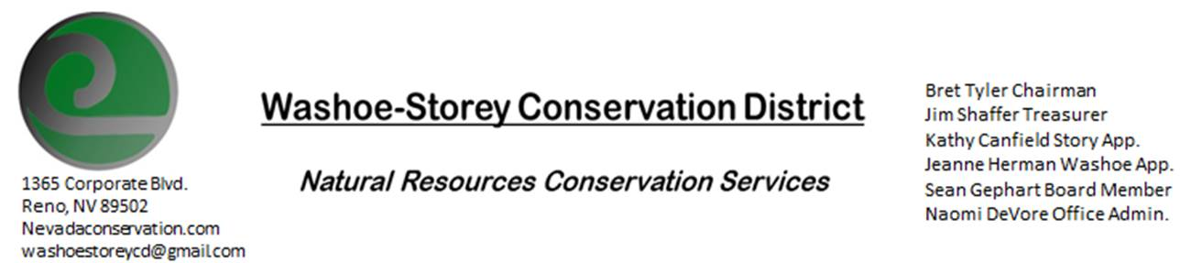
AGENDA 6/13/22
The Washoe-Storey Conservation District will hold a Public Meeting on
Monday, June 13, 2022. 3:30p.m.
The meeting will be held digitally on Google Meet and in person at the Reno Downtown Library 301 S. Center St.
to participate through Google Meet please send an email RSVP to washoestoreycd@gmail.com by June 12.
The Conservation District will consider and act on the following items unless otherwise noted:
I. Call to Order
A. Introductions, Determination of Board Quorum, and Introduction of Guests
B. Determination of agenda order – Agenda items may be taken out of order or deleted for lack of time

II. Public Comments-Public comment will be allowed at the beginning, after each item on the agenda and prior to the adjournment of every meeting. Public comment may be limited to three (3) minutes per comment.
III. District Projects – For Possible Action
A. Little Washoe Dam- Updates
B. Washoe County Planning Reviews- Updates
C. Storey County Projects – Grant Status for Storey County Weed Abatement
D. Upcoming Outreach and Community Projects – Potential Projects and Updates, River Justice Clean-Ups, Discuss to Decide which Native and Invasive Species will be included in our Nevada plants booklet and how these informational materials will be distributed to our desired demographic
E. Sage Grouse Projects- Sale of Sage Grouse Tags to NDOW

IV. External Agency Items and Reports – For Possible Action
A. NRCS – Jessica Gwerder– Local Work Group Meeting in August and other Updates
B. DCNR – Melany Aten – Updates
C. Sean Gephart- Updates
D. NVACD, Adjacent CD- Updates
E. NDOW- Partner Biologist- Victoria Cernoch- Sage Grouse Tags Follow Up
F. Truckee Meadows Regional Planning Agency- Updates
V. Internal District Issues – For Possible Action
A. Review, Amendment, and Approval of Minutes from previous meeting-
B. Financial Reports -Treasurer Jim Shaffer
- Treasurer's Report- Balances and Financial Reports
• Employee Salary- Review and Approve Payment for Employee Hours, Expenses paid for May
D. Office Updates

VI. Public Comments-Public comment will be allowed at the beginning, after each item on the agenda and prior to the adjournment of every meeting. Public comment may be limited to three (3) minutes per comment.
VII. Next Scheduled WSCD Board Meeting – (second Monday) July 11, 2022
VIII. Adjourn – Action

