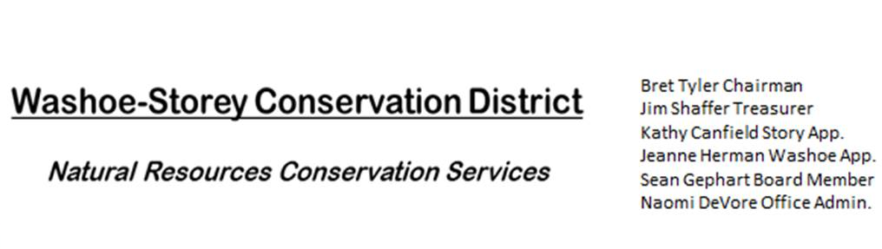
AGENDA 9/26/22
The Washoe-Storey Conservation District will hold a Public Meeting on
Monday, September 26, 2022. 3:30p.m.
The meeting will be held digitally on Google Meet and in person at the Reno Downtown Library 301 S. Center St.
to participate through Google Meet please send an email RSVP to washoestoreycd@gmail.com by Sept. 25.
The Conservation District will consider and act on the following items unless otherwise noted:
I. Call to Order
A. Introductions, Determination of Board Quorum, and Introduction of Guests
B. Determination of agenda order – Agenda items may be taken out of order or deleted for lack of time

II. Public Comments-Public comment will be allowed at the beginning, after each item on the agenda and prior to the adjournment of every meeting. Public comment may be limited to three (3) minutes per comment.
III. District Projects – For Possible Action
A. Washoe County Planning Reviews- Updates from Jim Shaffer
B. Storey County Projects – Grant Status for Storey County Weed Abatement, Next Actions
C. Outreach and Community Projects – Project Updates
D. Sage Grouse Projects- Fence Marker Invoice Updates

IV. External Agency Items and Reports – For Possible Action
A. NRCS – Jessica Gwerder– Updates
B. DCNR – Melany Aten – Updates
C. Sean Gephart- Updates
D. NVACD, Adjacent CD – Updates
E. NDOW- Partner Biologist- Victoria Cernoch- Updates
F. Truckee Meadows Regional Planning Agency- Updates
V. Internal District Issues – For Possible Action
A. Review, Amendment, and Approval of Minutes from Previous Meetings
B. Financial Reports -Treasurer Jim Shaffer
- Treasurer's Report- Balances and Financial Reports
• Employee Salary- Review and Approve Payment for Employee Hours & Mileage
C. Review: Review, Update and Approve Annual Plan and Budget Paperwork
D. Office Administration Progress and P.O. Box Address Updates
E. Review and Delegate Tasks to be completed by the Next Meeting

VI. Public Comments-Public comment will be allowed at the beginning, after each item on the agenda and prior to the adjournment of every meeting. Public comment may be limited to three (3) minutes per comment.
VII. Next Scheduled WSCD Board Meeting – (second Monday) October 10, 2022 at 3:30pm
VIII. Adjourn – Action

