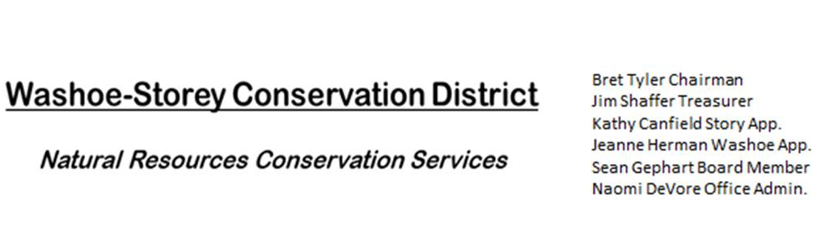
MINUTES 5/9/22
The Washoe-Storey Conservation District held a Public Meeting on
Monday, May 9, 2022. 3:30p.m.
The meeting will be held digitally on Google Meet and in person at the Reno Downtown Library 301 S. Center St.
to participate through Google Meet please send an email RSVP to washoestoreycd@gmail.com by May 8.
The Conservation District will consider and act on the following items unless otherwise noted:
I. Call to Order
A. Introductions, Determination of Board Quorum, and Introduction of Guests: Jim Shaffer, Sean Gephart, Bret Tyler, and Naomi De Vore attended in person. Kathy Canfield joined via Google Meet.
B. Determination of agenda order – Agenda items may be taken out of order or deleted for lack of time

II. Public Comments-Public comment will be allowed at the beginning, after each item on the agenda and prior to the adjournment of every meeting. Public comment may be limited to three (3) minutes per comment.
III. District Projects – For Possible Action
A. Little Washoe Dam- No Updates
B. Washoe County Planning Reviews- 16 reviews were submitted. Most were small projects and half received no comments from WSCD. One of the projects included reseeding near Lake Tahoe.
C. Storey County Projects – Finalize Grant for Storey County Weed Abatement. The grant would be available in summer or fall. Since the herbicides listed are for summer application, we will be turning the grant in to Kathy by May 10. We would like to add broader effects of poison hemlock as well as an opportunity for a community lending library for the tools purchased for the project which would make this equipment available to local residents at the Senior Center or Community Center in Lockwood.
D. Upcoming Outreach and Community Projects – The board approved a $600 budget for artists to create accurate depictions for our Nevada Invasive Weed Booklet. Jim made the motion & Kathy seconds. This would allow us to hire artists to create artwork of enhanced realistic images for identification. Our next goal is to do more outreach to motivate community weed abatement and river clean up events.
E. Sage Grouse Projects- Sale of Sage Grouse Tags to NDOW. NDOW would like to purchase 4,000 light colored sage grouse tags. We have recommended multi-colored tags but will inventory and provide only light colored tags as requested.

IV. External Agency Items and Reports – For Possible Action
A. NRCS – Jessica Gwerder– No updates.
B. DCNR – Melany Aten – Proposed Work Plan is due June 1, 2022.
C. Sean Gephart- Nevada Weed management association will hold a statewide meeting on the 16, 17, 18- Sean will forward the meeting link to the rest of the board.
D. NVACD, Adjacent CD- Bret has been receiving project updates from Lander County Conservation District.
E. NDOW- Partner Biologist- Tori Cernoch – Tori has been coordinating the purchase of Sage Grouse Tags.
F. Truckee Meadows Regional Planning Agency- No Updates
V. Internal District Issues – For Possible Action
A. Review, Amendment, and Approval of Minutes from previous meeting-
B. Financial Reports -Treasurer Jim Shaffer
- Treasurer's Report- Balances and Financial Reports- Checking: $4,684.98/ Mitigation: $19, 226.88
• Employee Salary- Review and Approve Payment for Employee Hours for April- 15 Hours= $255
C. Review, Update and Approve Proposed Work Plan by June 1- Treasurer Jim Shaffer provided an outline of the budget and Naomi revised last year’s work plan to reflect our current actions and goals. This plan was approved and will be submitted by the end of the month.
D. Office Updates – we have a new mailing address and will be moving our belongings out of the NRCS office as they downsize this summer. We will be transferring our mail to this new address near the downtown library
135 N. Sierra Street A1, Reno NV 89501
P.O. Box # 40538

VI. Public Comments-Public comment will be allowed at the beginning, after each item on the agenda and prior to the adjournment of every meeting. Public comment may be limited to three (3) minutes per comment.
VII. Next Scheduled WSCD Board Meeting – (second Monday) June 13, 2022
VIII. Adjourn – Action

