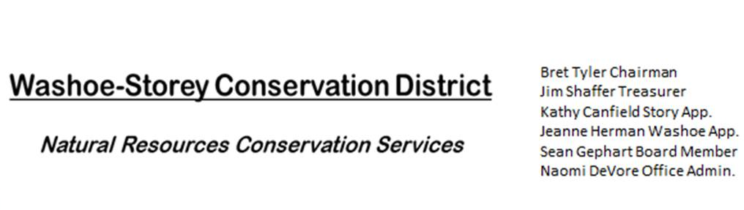
MINUTES 8/8/22
The Washoe-Storey Conservation District held a Public Meeting on
Monday, August 8, 2022. 3:30p.m.
The meeting will be held digitally on Google Meet and in person at the Reno Downtown Library 301 S. Center St.
to participate through Google Meet please send an email RSVP to washoestoreycd@gmail.com.
The Conservation District will consider and act on the following items unless otherwise noted:
I. Call to Order
A. Introductions, Determination of Board Quorum, and Introduction of Guests: Bret Tyler, Jim Shaffer, Kathy Canfield, Melany Aten, Jessica Gwerder, Honey Menefee from Storey County, Jake Dick from NDA, Bob and Lisa Holleman from the Architectural Review Board and Rainbow Bend Landscape Committee.
B. Determination of agenda order – Agenda items may be taken out of order or deleted for lack of time

II. Public Comments-Public comment will be allowed at the beginning, after each item on the agenda and prior to the adjournment of every meeting. Public comment may be limited to three (3) minutes per comment.
- Lisa Holleman: There is 2 new pipelines in Lockwood along Canyon Way which will cross the creek today. She comments that we should include a chipper, and increase the ask for the grant. Bob and Lisa have already gathered a crew of volunteers invested in working to remove the weeds along the river and were able to give us important contact information.
III. District Projects – For Possible Action
A. Washoe County Planning Reviews- Updates from Jim Shaffer – 8 small projects were reviewed for Washoe
B. Storey County Projects – Our final draft of the grant for Storey County Weed Abatement will be submitted
Melany may have crew options for 6 mile Canyon
C. Outreach and Community Projects – Bret has been putting together an outline for the invasive species booklets. Naomi produced small informational booklets about the weed removal project which we distributed to residents at a community event at Perri Park in Lockwood
D. Sage Grouse Projects- We’ll need to produce more white tags so that we can provide an even amount of dark and light colored fence markers for our next sale.

IV. External Agency Items and Reports – For Possible Action
A. NRCS – Jessica Gwerder– Local Work Group Meeting Updates : Our priority resourse concerns which we agreed upon during the recent LWG meeting were 1. Weeds, 2. Fuels/ fire, 3. Water Quality/ Quantity a. livestock water b. flood plain and flood way protection. We also discussed how NRCS has not kept up with inflation when offering support for certain costs
B. DCNR – Melany Aten – Suggests that we add advertising to that we’ll have 5 elected supervisors and atleast 2 active appointed supervisors. We also want to reach out to Reno and Sparks for City Appointments.
C. Sean Gephart- No Updates
D. NVACD, Adjacent CD – Updates
E. NDOW- Partner Biologist- Victoria Cernoch- No Updates
F. Truckee Meadows Regional Planning Agency- Updates
V. Internal District Issues – For Possible Action
A. Review, Amendment, and Approval of Minutes and Recap from Previous Meeting – Tabled until next meeting
B. Financial Reports -Treasurer Jim Shaffer
- Treasurer's Report- Balances and Financial Reports: Checking $2,717. 40/ Mitigation $19,181.61
• Employee Salary- Review and Approve Payment for 19 Employee Hours & July Expenses (Mileage) and Reimbursements- Kathy makes the motion and Bret seconds
* Upcoming Deadlines – Annual Plan and Budget Paperwork will be approved at our next meeting and turned in by Sept. 30
D. Office and P.O. Box Updates: We’ll need our tax ID #, Melany will be able to find this information

VI. Public Comments-Public comment will be allowed at the beginning, after each item on the agenda and prior to the adjournment of every meeting. Public comment may be limited to three (3) minutes per comment.

- Jake Dick – NDA – Shared a Request for Proposals with a 1 to 1 match due October 21
  - Purple Loosestrife has been found in Long Valley Creek Canyon
VII. Next Scheduled WSCD Board Meeting – September 26, 2022 at 3:30pm
VIII. Adjourn – Action

