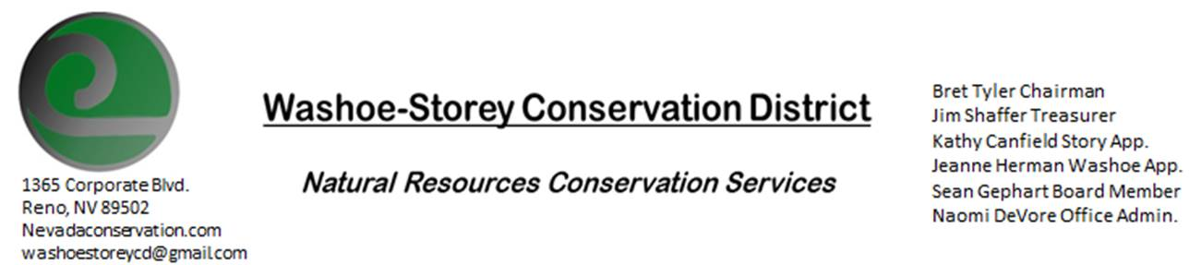
MINUTES 4/11/22
The Washoe-Storey Conservation District held a Public Meeting on
Monday, April 11, 2022. 3:30p.m.
The meeting will be held digitally on Google Meet and in person at the Reno Downtown Library 301 S. Center St.
to participate through Google Meet please send an email RSVP to washoestoreycd@gmail.com by April 10.
The Conservation District will consider and act on the following items unless otherwise noted:
I. Call to Order
A. Introductions, Determination of Board Quorum, and Introduction of Guests: Jessica Gwerder, Bret Tyler, Kathy Canfield, Sean Gephart, Naomi De Vore
B. Determination of agenda order – Agenda items may be taken out of order or deleted for lack of time

II. Public Comments-Public comment will be allowed at the beginning, after each item on the agenda and prior to the adjournment of every meeting. Public comment may be limited to three (3) minutes per comment. No public comments at this time.
III. District Projects – For Possible Action
A. Little Washoe Dam- No Updates
B. Washoe County Planning Reviews- No Updates
C. Storey County Projects – Naomi sent a preliminary proposal for the grant we’ve been working on to Jim and Sean. Sean was able to make some meaningful additions and adjustments before we turn this paperwork in. We’ll look at this further during our next meeting.
D. Upcoming Outreach and Community Projects – Potential Projects and Updates

IV. External Agency Items and Reports – For Possible Action
A. NRCS – Jessica Gwerder– Local Work Group Meeting will be hosted in August this year, we’d like to collaborate with Carson Valley again this year to receive input and feedback from the greater area.
B. DCNR – Melany Aten – No Updates
C. Sean Gephart- Updates
D. NVACD, Adjacent CD- Updates
E. NDOW- Partner Biologist- Victoria Cernoch- Tori was not able to attend the meeting today but we have been discussing NDOW’s intent to purchase 4,000 light colored sage grouse tags
F. Truckee Meadows Regional Planning Agency- A meeting was hosted recently.
V. Internal District Issues – For Possible Action
A. Review, Amendment, and Approval of Minutes from previous 2 meetings- Bret makes a motion to approve the minutes from February 7 and March 14. The motion carries unanimously
B. Financial Reports -Treasurer Jim Shaffer not in attendance, we will follow up at our next meeting
- Treasurer's Report- Balances and Financial Reports
• Employee Salary- Review and Approve Payment for Employee Hours for March- Bret makes the motion and it carries unanimously
D. Office Updates

VI. Public Comments-Public comment will be allowed at the beginning, after each item on the agenda and prior to the adjournment of every meeting. Public comment may be limited to three (3) minutes per comment.
VII. Next Scheduled WSCD Board Meeting – (second Monday) May 9
VIII. Adjourn – Action

