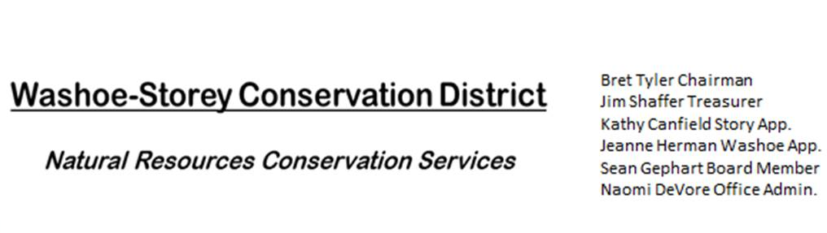
MINUTES 9/26/22
The Washoe-Storey Conservation District held a Public Meeting on
Monday, September 26, 2022. 3:30p.m.
The meeting will be held digitally on Google Meet and in person at the Reno Downtown Library 301 S. Center St.
to participate through Google Meet please send an email RSVP to washoestoreycd@gmail.com.
The Conservation District will consider and act on the following items unless otherwise noted:
I. Call to Order
A. Introductions, Determination of Board Quorum, and Introduction of Guests:
Bob Holleman, Bret Tyler, Jim Shaffer, Naomi DeVore, Kathy Canfield and Sean Gephart joined by phone.
B. Determination of agenda order – Agenda items may be taken out of order or deleted for lack of time

II. Public Comments-Public comment will be allowed at the beginning, after each item on the agenda and prior to the adjournment of every meeting. Public comment may be limited to three (3) minutes per comment.
III. District Projects – For Possible Action
A. Washoe County Planning Reviews- Updates from Jim Shaffer
B. Storey County Projects – After being approved for the grant from Storey County, we solidified a timeline to complete the project and specified which herbicides will need to be purchased. Bob Holleman and the Rainbow Bend HOA will be meeting tomorrow on this subject.
C. Outreach and Community Projects –
D. Sage Grouse Projects- Fence Marker Invoice-No Updates

IV. External Agency Items and Reports – For Possible Action
A. NRCS – Jessica Gwerder– No Updates
B. DCNR – Melany Aten – No Updates
C. Sean Gephart- The Nevada Weed Management Conference is coming up on October 18 and 19. Bret, Naomi and Sean will be present. Jim Shaffer makes a motion to approve payment for the registration fee and Kathy Canfield seconds.
D. NVACD, Adjacent CD – No Updates
E. NDOW- Partner Biologist- Victoria Cernoch- No Updates
F. Truckee Meadows Regional Planning Agency- No Updates
V. Internal District Issues – For Possible Action
A. Review, Amendment, and Approval of Minutes from Previous Meetings
B. Financial Reports -Treasurer Jim Shaffer
- Treasurer's Report- Balances and Financial Reports: Checking- $1,497.75, Mitigation/Savings: $19,151.61
• Employee Salary- Review and Approve Payment for 21 Employee Hours for August & 17 hours for September. Bret makes a motion to approve the financial report, Kathy Canfield seconds.
C. Review: Review, Update and Approve Annual Plan and Budget Paperwork . Bret motions to approve the annual plan and financial report, Jim Shaffer seconds.
D. Office Administration Progress and P.O. Box Address- No Updates
E. Review and Delegate Tasks to be completed by the Next Meeting : Prior to the next meeting, Naomi will resend updated project plans for Rainbow Bend to relevant parties, submit our annual reporting paperwork, and register for the NV Weed Management Conference.

VI. Public Comments-Public comment will be allowed at the beginning, after each item on the agenda and prior to the adjournment of every meeting. Public comment may be limited to three (3) minutes per comment.
Thank you from Bob Holleman and the community which will benefit from the weed removal project in Rainbow Bend in Lockwood, NV. Bob and his team are willing to begin immediately cleaning up the riverbanks with assistance from the grant from Storey County and we are all very grateful for their efforts in bringing this project to fruition.
VII. Next Scheduled WSCD Board Meeting – (second Monday) October 10, 2022 at 3:30pm
VIII. Adjourn – Action

