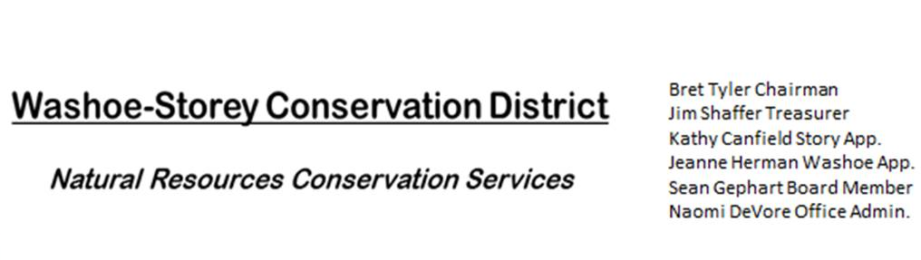
AGENDA 01/09/23
The Washoe-Storey Conservation District will hold a Public Meeting on
Monday, January 9, 2022. 3:30 p.m.
The meeting will be held digitally online and in person at the Reno Downtown Library 301 S. Center St.
to participate through Google Meet please RSVP to washoestoreycd@gmail.com by January 8.

The Conservation District will consider and act on the following items unless otherwise noted:
I. Call to Order
A. Introductions, Determination of Board Quorum, and Introduction of Guests
B. Determination of agenda order – Agenda items may be taken out of order or deleted for lack of time

II. Public Comments-Public comment will be allowed at the beginning, after each item on the agenda and prior to the adjournment of every meeting. Public comment may be limited to three (3) minutes per comment.
III. District Projects – For Possible Action
A. Washoe County Planning Reviews- Updates from Jim Shaffer
B. Storey County Projects – Updates and Next Actions on Rainbow Bend Weed Abatement
C. Outreach and Community Projects – Updates

D. Sage Grouse Projects - Delegate funds to purchase material to make light colored sage grouse tags.

IV. External Agency Items and Reports – For Possible Action
A. NRCS – Jessica Gwerder– Updates
B. DCNR – Melany Aten – Updates
C. Sean Gephart- Updates
D. NVACD, Adjacent CD – Annual Meeting Updates
E. NDOW- Partner Biologist- Victoria Cernoch- Updates
V. Internal District Issues – For Possible Action
A. Review, Amendment, and Approval of Minutes from Previous Meetings
B. Financial Reports -Treasurer Jim Shaffer
- Treasurer's Report- Balances and Financial Reports -
• Employee Salary- Review and Approve Payment for December Employee Hours and expenses
C. Review and Delegate Tasks to be completed by the Next Meeting

VI. Public Comments-Public comment will be allowed at the beginning, after each item on the agenda and prior to the adjournment of every meeting. Public comment may be limited to three (3) minutes per comment.
VII. Next Scheduled WSCD Board Meeting – (second Monday) February 13, 2023 at 3:30pm
VIII. Adjourn – Action

