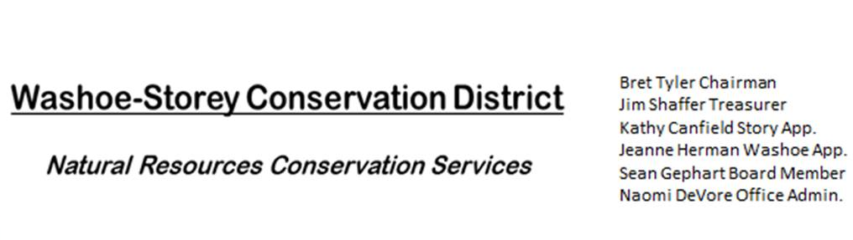AGENDA 04/17/23
The Washoe-Storey Conservation District will hold a Public Meeting on
Monday, April 17, 2022. 3:30 p.m.
The meeting will be held digitally online and in person at the
Nevada Department of Agriculture 405 21st St, Sparks, NV 89431
to participate online please RSVP to washoestoreycd@gmail.com by April 17.

The Conservation District will consider and act on the following items unless otherwise noted:
I. Call to Order
A. Introductions, Determination of Board Quorum, and Introduction of Guests
B. Determination of agenda order – Agenda items may be taken out of order or deleted for lack of time
II. Public Comments-Public comment will be allowed at the beginning, after each item on the agenda and prior to the adjournment of every meeting. Public comment may be limited to three (3) minutes per comment.
III. District Projects – For Possible Action
A. Washoe County Planning Reviews- Updates from Jim Shaffer
B. Storey County Projects – Updates and Next Actions on Rainbow Bend Weed Abatement, Grant dispersal Aquiring tools, Communications with State Lands and Liability Updates. Review and Approval for Next Steps in April and May. Completion of the project deadline is June 30.
C. Outreach and Community Projects – ISO Volunteers and additional WSCD Board Members

D. Sage Grouse Projects - Delegate funds to purchase material to make light colored sage grouse tags.
IV. External Agency Items and Reports – For Possible Action
A. NRCS – Jessica Gwerder– Updates
B. DCNR – Melany Aten – Updates on State Funds. $4,108.33 March 30.
C. Sean Gephart- Updates
D. NVACD, Adjacent CD – Annual Meeting Updates
E. NDOW- Partner Biologist- Victoria Cernoch- Updates
V. Internal District Issues – For Possible Action
A. Review, Amendment, and Approval of Minutes from Previous Meeting
B. Financial Reports -Treasurer Jim Shaffer
- Treasurer's Report- Balances and Financial Reports, Delegate Funds from Washoe and Storey Counties and the State of Nevada
• Employee Salary- Review and Approve Payment for Employee Hours and Expenses
C. Updates on Enrollment in Liability Insurance from Pool-Pact
D. Review and Delegate Tasks to be completed by the Next Meeting
VI. Public Comments-Public comment will be allowed at the beginning, after each item on the agenda and prior to the adjournment of every meeting. Public comment may be limited to three (3) minutes per comment.
VII. Next Scheduled WSCD Board Meeting – (second Monday) May 1, 2023 at 3:30pm VIII. Adjourn – Action

