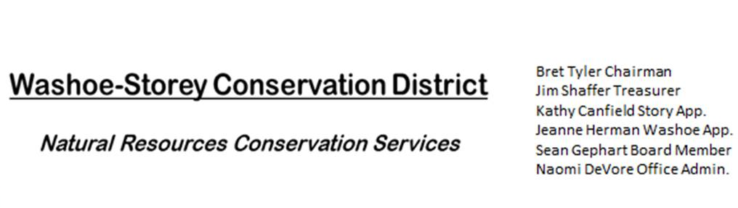
MINUTES 11/7/22

The Washoe Storey Conservation District held a public election on Monday Nov. 7 at 3:30p.m. at a public polling place Reno Downtown Library 301 S. Center St.
Treasurer Jim Shaffer ran for reelection unopposed.
The Washoe-Storey Conservation District will held a Public Meeting on
Monday, November 7, 2022. 4:00 p.m.
The meeting will be held digitally on Google Meet and in person at the Reno Downtown Library 301 S. Center St.
to participate through Google Meet please send an email RSVP to washoestoreycd@gmail.com by November 6.
The Conservation District will consider and act on the following items unless otherwise noted:
I. Call to Order
A. Introductions, Determination of Board Quorum, and Introduction of Guests : Sean Gephart, Bret Tyler, Kathy Canfield, Jessica Gwerder, Melany Aten, and Lisa Holleman met remotely; Jim Shaffer, Naomi De Vore, and Bob Holleman met in person.
B. Determination of agenda order – Agenda items may be taken out of order or deleted for lack of time:

II. Public Comments-Public comment will be allowed at the beginning, after each item on the agenda and prior to the adjournment of every meeting. Public comment may be limited to three (3) minutes per comment.
Bob Holleman hosted a clean up event on October 16 along the Truckee River at Rainbow Bend in Lockwood, Nevada. The event was well attended by volunteers and the Storey County Fire Department. ½ Acre path was cleared up and they plan to finish the job in November. Small amounts of poison hemlock were discovered, the volunteer crews removed mostly woody debris that blocked access to the path and riverbanks. The grant from Storey County was not able to cover tool costs for this portion of the project, but we will begin weed treatments and reseeding in the spring.
III. District Projects – For Possible Action
A. Washoe County Planning Reviews- Updates from Jim Shaffer – 11 projects were reviewed in October including a private school in Washoe Valley.
B. Storey County Projects – Updates and Next Actions on Rainbow Bend Weed Abatement – Long Valley Creek is working on a planning grant to identify future mitigation and safety projects related to flooding in that area. There will be an upcoming community meeting to gather information and public participation from community members
C. Outreach and Community Projects – Project Updates
D. Sage Grouse Projects- Fence Marker Updates - We will plan to purchase materials to make light colored sage grouse fence markers in January

IV. External Agency Items and Reports – For Possible Action
A. NRCS – Jessica Gwerder– Updates - Trina Johnson was promoted from Minden to the state office. EQUIP and AMA 2023 has an application deadline of November 19. November 9 at 9am – 2:30pm is the STAT meeting at the NDA office.
B. DCNR – Melany Aten – Annual Plans were received and submitted for funding approval. The Annual Meeting in Fallon is coming up. The department is still working on hiring a Western Region staff specialist.
C. Sean Gephart- Updates- Nevada Weed Management Conference had 200 in attendance. Sean continues to work on vegetation management on ground utility lines, Sean can provide example photographs of this for the weed booklet.
D. NVACD, Adjacent CD – Naomi will attend the Upcoming Annual Meeting in Fallon Nov 15-17
E. NDOW- Partner Biologist- Victoria Cernoch- No Updates
F. Truckee Meadows Regional Planning Agency- No Updates
V. Internal District Issues – For Possible Action
A. Review, Amendment, and Approval of Minutes from Previous Meeting – Tabled to January Meeting
B. Financial Reports -Treasurer Jim Shaffer
- Treasurer's Report- Balances and Financial Reports : 2,232.46 in Checking, 19,136.61 in Savings.
• Employee Salary- Review and Approve Payment for Employee Hours & Mileage. 26 hours + Fallon Travel Expenses
D. Board Member Election – Jim Shaffer was reelected as treasurer for a 4 year term from 2022-2026.

VI. Public Comments-Public comment will be allowed at the beginning, after each item on the agenda and prior to the adjournment of every meeting. Public comment may be limited to three (3) minutes per comment.
VII. Next Scheduled WSCD Board Meeting – (second Monday) January 9, 2023 at 3:30pm
VIII. Adjourn – Action

